WALKER SOCCER

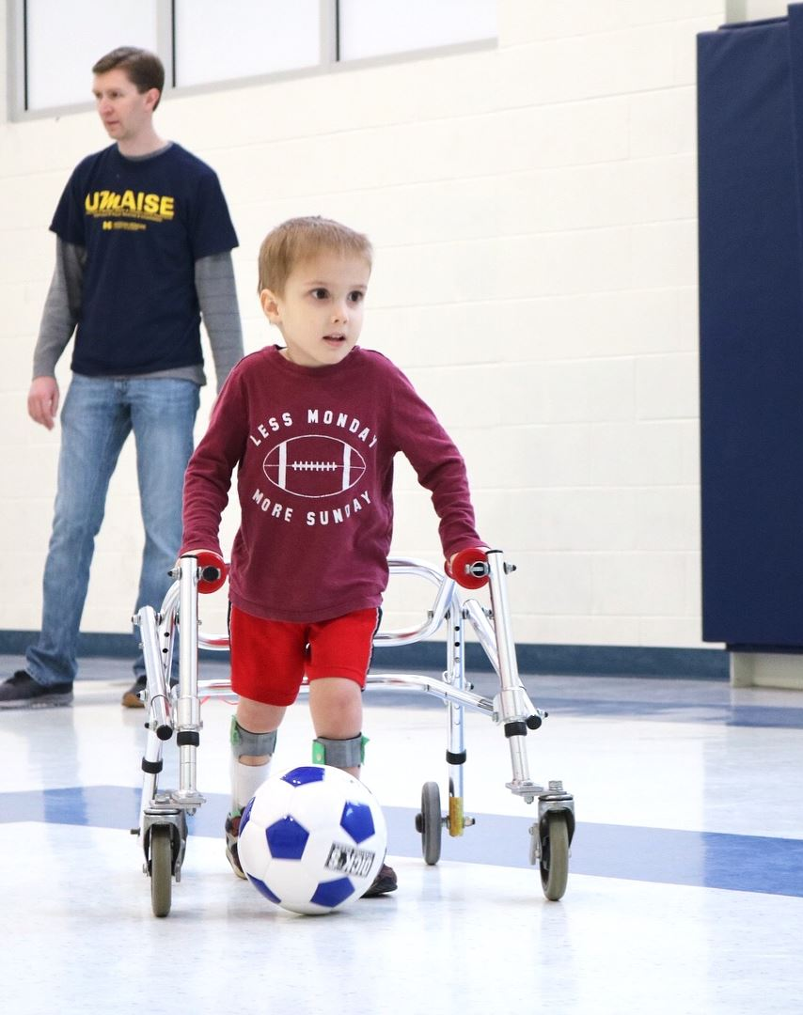

6 Week Session
Peace Lutheran Church Gym
8260 Jackson Rd.
Ann Arbor, MI 48103
April 6 – May 18
NO PRACTICE - April 27th
Our Walker Soccer program is open to Children ages 5 to 18 who have limited mobility. Players may walk, use a walker, or wheelchair.

Saturday Mornings
Spring 2019
10:00 AM – 11:30 AM

Please Send Questions and Completed forms to:
PMR-UMAISETR@UMICH.EDU
or contact us with any questions

REGISTRATION INFORMATION
Participant’s Name: Click or tap here to enter text. Date of Birth: Click or tap here to enter text.
Parent/Guardian Name (if under 18 yo): Click or tap here to enter text.
Best Contact ph # : Click or tap here to enter text. Email Address: Click or tap here to enter text.
**We utilize Mobilize for communication (app available for iPhone/Android; also works with text message or email)**
I authorize UMAISE representatives to contact me via mobilize/email/text message: YES ☐ NO ☐
Additional Emergency Contact(s)/Relation: Click or tap here to enter text.
Participant or Parent/Guardian address: Click or tap here to enter text.
Special considerations/Allergies: Click or tap here to enter text.
Does participant use assistive device (wheelchair, crutches, walker) for mobility? If yes, please explain.
Click or tap here to enter text.
In the event that I am unavailable, I authorize Michigan Medicine staff to seek medical treatment for me/my child.
YES ☐ NO ☐ Initial Here: Click or tap here to enter text.
PCP/Pediatrician name and phone number: Click or tap here to enter text.
Walker Soccer -- My child will be using a: Walker ☐ Wheelchair ☐ No device ☐
Click or tap here to enter text.
Signature of participant or Parent/Guardian (if under 18 yo) check box if e-signed☐
Date of signing: Click or tap to enter a date.

