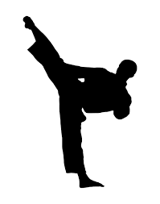
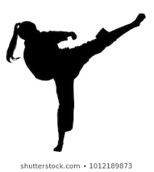
Martial Arts Therapy

Led by sensei Dave Reicher, and co–led by therapy staff, this therapy utilizes martial arts to increase balance, coordination, endurance, and strength. Martial Arts Therapy also aids in improving self-esteem while providing opportunities for positive social interaction.
Through guidance and adaptive techniques, this therapy assists participants in learning how to successfully participate in the recreational and fitness activity of martial arts regardless of physical, cognitive, social or emotional condition.
Kicking off on September 10th, classes are offered Tuesdays at 5:30 and 6:30 p.m. at the University of Michigan Pediatric Rehabilitation Center.
2205 Commonwealth Blvd
Ann Arbor, MI 48105
Classes run in 6 week sessions throughout the school year
Martial Arts Therapy is funded in part by a generous grant through
Dance Marathon at the University of Michigan.
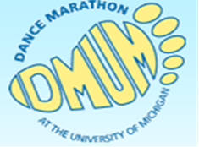
To register for Martial Arts Therapy, or for questions, please call Dave Reicher at 517-375-0252

