ROLLVERINES BASKETBALL

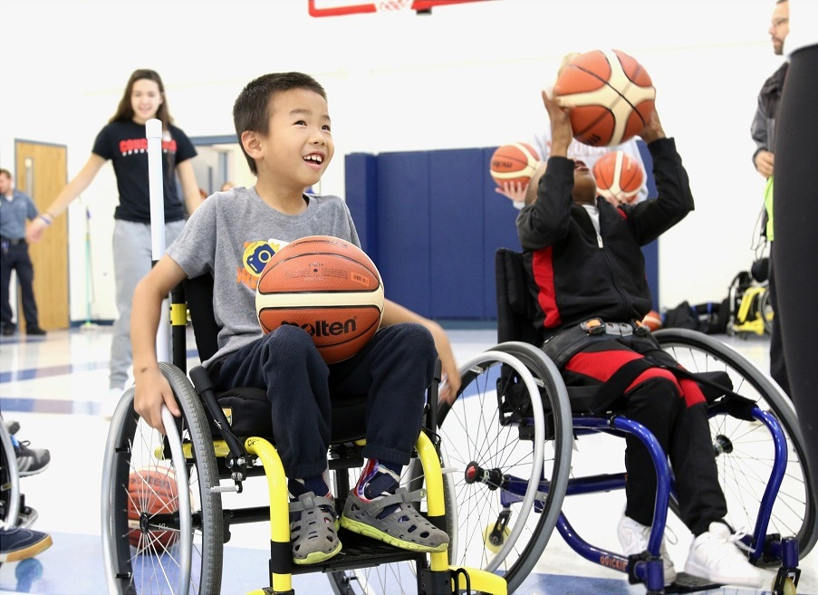
Our Jr. Wheelchair basketball team is open to youth with physical impairments limiting their ability to participate in able-bodied basketball.
Recreational & Competition Teams
Weekly Practices:
Mondays
6:00 - 7:30 PM
Peace Lutheran
8260 Jackson Rd.,
Ann Arbor
Sport wheelchairs provided

2018-2019 practice schedule

Consider joining us at a practice or clinic!
PMR-UMAISETR@UMICH.EDU
Please contact us with any questions
Please Join Us!
Our Team is always welcoming new members!

REGISTRATION INFORMATION
Participant’s Name: Click or tap here to enter text. Date of Birth: Click or tap here to enter text.
Parent/Guardian Name (if under 18 yo): Click or tap here to enter text.
Best Contact ph # : Click or tap here to enter text. Email Address: Click or tap here to enter text.
Additional Emergency Contact(s)/Relation: Click or tap here to enter text.
Participant or Parent/Guardian address: Click or tap here to enter text.
Special considerations/Allergies: Click or tap here to enter text.
Does participant use assistive device (wheelchair, crutches, walker) for mobility? If yes, please explain.
Click or tap here to enter text.
In the event that I am unavailable, I authorize Michigan Medicine staff to seek medical treatment for me/my child. YES ☐ NO ☐ Initial Here: Click or tap here to enter text.
PCP/Pediatrician name and phone number: Click or tap here to enter text.
**We utilize Mobilize for communication (app available for iPhone/Android; also works with text message or email)
Phone Number (if different from above): Click or tap here to enter text.
Email (if different from above): Click or tap here to enter text.
I authorize UMAISE representatives to contact me via mobilize/email/text message: YES ☐ NO ☐
Click or tap here to enter text.
Signature of participant or Parent/Guardian (if under 18 yo) Check if e-signed ☐ Date Click or tap to enter a date.

