Directions:
The colloquium will be held in the Molecular Plant and Soil Sciences building and parking is available in the Wharton Center parking structure (see map below). The entrance to the parking structure is on East Shaw Lane. I recommend entering campus via Trowbridge Road off of I-496 to avoid construction. Please note: If you are using Google Maps/Mapquest/Waze, the directions are great until you get on campus. Therefore, please refer to the written instructions as well as the map below for the “Once on campus” instructions.

From Wayne State

- Take M-10 North.
- Take exit 18C for I-696 W toward Lansing
- I-696 merges into I-96 W.
- Stay on I-96 and take exit 106B for I-496 (US-127 North)
- Take exit 9 to merge onto Trowbridge.
- Use the “once on campus” directions and the map below.

From University of Michigan

- Take M-14 to US-23 North.
- Take US-23 North towards Brighton
- Take Exit 60B (on the left) for I-96 West toward Lansing
- Stay on I-96 and take exit 106B for I-496
- Take exit 9 to merge onto Trowbridge.
- Use the “once on campus” directions and the map below.

From University of Toledo

- Merge onto I-475 West
- Take exit 14 for US-23 North towards Sylvania/Ann Arbor
- Continue on US-23 North
- Keep right to stay on US-23 North
- Take Exit 60B (on the left) for I-96 West toward Lansing
- Stay on I-96 and take exit 106B for I-496
- Take exit 9 to merge onto Trowbridge.
- Use the “once on campus” directions and the map below.

Once on campus:

- Continue down Trowbridge Road, which turns into Red Cedar Road.
- From Red Cedar Road, turn right on South Shaw Lane.
- Continue down South Shaw Lane until it turns into East Shaw Lane.
- From East Shaw lane, turn right into the parking structure for the Wharton center. The entrance to the parking structure will be across from a building called Owen Hall.
- Once you have parked, exit the structure to the south to Wilson Road.
- Cross Wilson Road (the Veterinary Medical School should be in front of you).
- Turn right and cross Bogue Street.
- Molecular Plant and Soil Sciences is the giant glass building pictured below.
- Enter the building through the doors on Wilson Road.

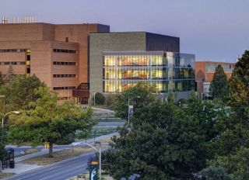
Molecular Plant and Soil Sciences
(Photo taken from the Wharton parking structure)

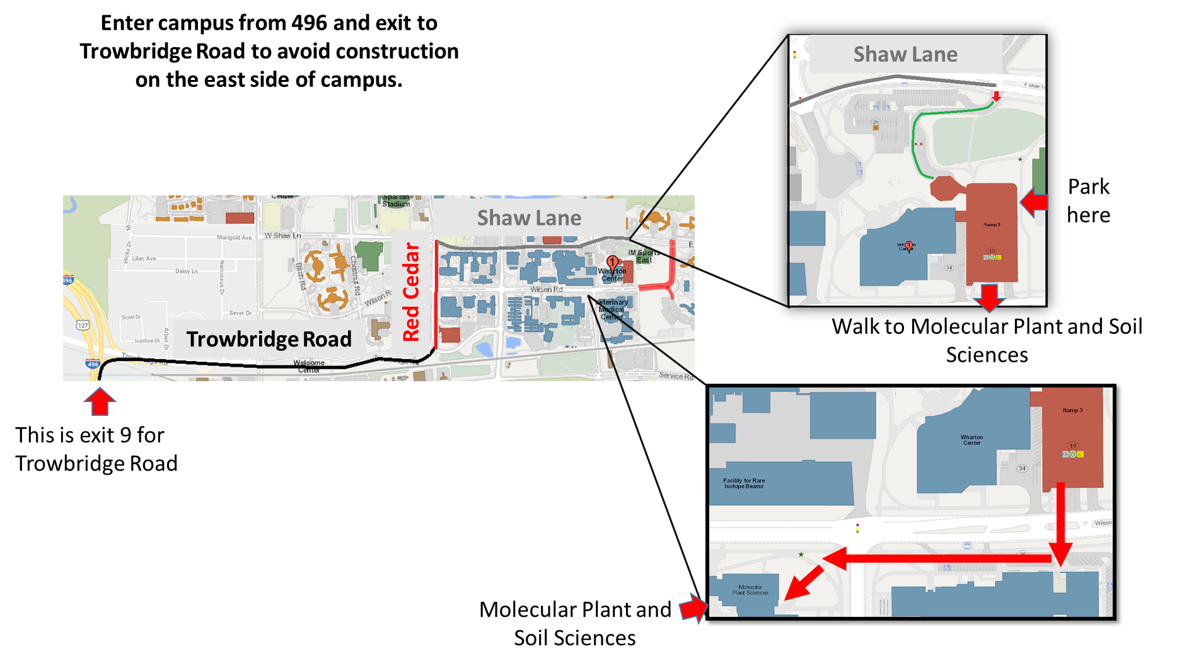
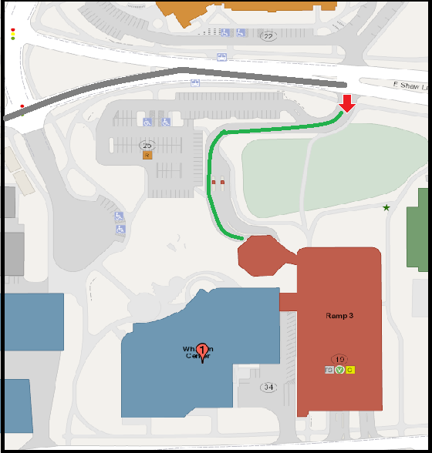
Trowbridge Road
Red Cedar
Shaw Lane
Shaw Lane

