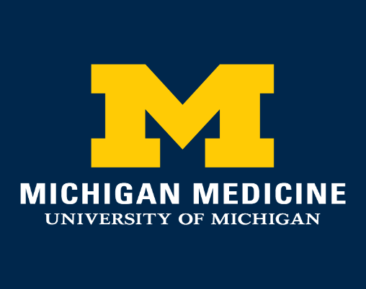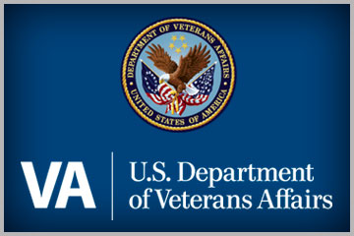

**2022 MICHIGAN MEDICINE AND VA ANN ARBOR HEALTHCARE SYSTEM POSTDOCTORAL CONSORTIUM IN CLINICAL NEUROPSYCHOLOGY**

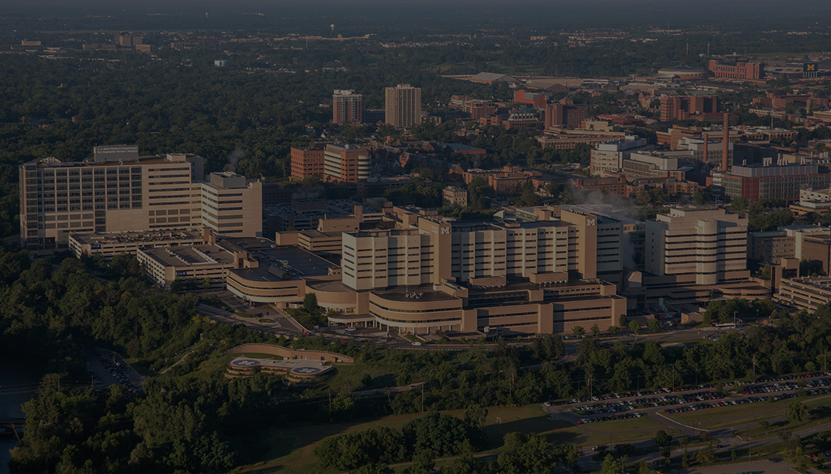

**Five positions anticipated beginning in September 2022**

* **2 Adult Positions at Michigan Medicine**
* **2 Adult Positions at VA Ann Arbor Healthcare System**
* **1 Pediatric Position at Michigan Medicine**

**Application Deadline: December 1, 2021**

Submission of materials is done electronically at the following website: <https://medicine.umich.edu/dept/psychiatry/education/psychology-postdoctoral-training/how-apply>

**ACCREDITED BY THE COMMISSION ON ACCREDITATION**

**AND THE AMERICAN PSYCHOLOGICAL ASSOCIATION**

The University of Michigan, as an equal opportunity/affirmative action employer, complies with all applicable federal and state laws regarding nondiscrimination and affirmative action. The University of Michigan is committed to a policy of equal opportunity for all persons and does not discriminate on the basis of race, color, national origin, age, marital status, sex, sexual orientation, gender identity, gender expression, disability, religion, height, weight, or veteran status in employment, educational programs and activities, and admissions

**Table of Contents**

**Consortium Overview**….………………….…………………............................................ 3

Michigan Medicine Neuropsychology Program Site ………………………………… 4

Michigan Medicine Facilities………………………………………………………… 4

VAAAHS Neuropsychology Program Site……………………………………………….. 5

VAAAHS Facilities……………………………………………………………………. 5

**Education**………..……….……………….…………………………………………………… 6

Required……………………………………………………………………………………. 6

Optional…………………………………………………………………………………….. 6

Teaching/Supervision Experiences……………………………………………………… 8

**Adult Neuropsychology – Clinical Training Experiences**….…….…………………… 8

Michigan Medicine……..……………..…………………………………………………….. 8

General Neuropsychology Clinic……………………………………………………. 8

Primary Clinical Experiences………………………………………………….......... 8

Cognitive Disorders Clinic…………………………………………………......... . 8

Epilepsy Program…………………………………………………………………. 8

Pediatric Clinics……………………………………………………………………. 9

Optional Clinical Experiences……………………………………………………. 9

VA Ann Arbor Healthcare System………………………………………………………… 9

General Neuropsychology Clinic…………………………………………….............. 9

Primary Clinic Experiences………………………………………………................... 9

VAAAHS Polytrauma Clinic………………………………………………............. 9

Geriatric Medicine Clinic………………………………………………………….. 10

Community Living Center…………………………………………………………. 10

Optional Training Experiences…………………………………………………….10

**Adult Neuropsychology – Research Experiences**…………………………………….. 11

Michigan Medicine………………..………………………………………………............ 11

Adult Neuromedical……..……………………………………………………………. 11

Geriatric/Dementia………..………………………………………………................ 12

VA Ann Arbor Healthcare System………..……………………………………………… 14

Academic Track...………………………………………...………………….............. 14  
Generalist Track………………………………………………………………………. 14

**Pediatric Neuropsychology–Clinical Training Experiences**.........................……… 15

General Neuropsychology Clinic………………………………………………............... 15

Primary Clinical Experiences…………………………………………………………….. 15

**Pediatric Neuropsychology – Research Experiences**………………………………... 16

**Current Residents**…………………………………………………………………………… 17

**Neuropsychology Consortium Training Directors**……………………………………..18

**Additional Principal Training Faculty**………...…………………………….……………. 19

**Clinical Neuropsychology Application Process**…….……....……………………… … 26

**Ann Arbor Life and Community**………..…………………….…………………………… 27

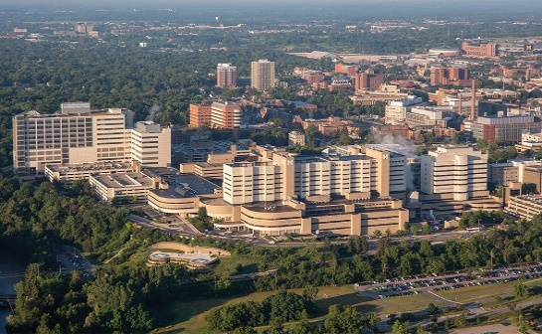**Michigan Medicine/VAAAHS Consortium**

Michigan Medicine and the VA Ann Arbor Healthcare System (VAAAHS) have combined to form a network of training programs that provide rich interdisciplinary training environments in multiple specialty areas. The Network Training Director is J. Todd Arnedt, Ph.D. and the Neuropsychology Program Training Directors are Kristen Votruba, Ph.D. ABPP-CN (Michigan Medicine) and Robert Spencer, Ph.D. (VAAAHS). The Neuropsychology consortium is accredited for specialty training by the American Psychological Association (APA).

The neuropsychology program adheres to a scientist-practitioner model with a mission of contributing to the development of competent clinical psychologists with a specialization in neuropsychology and preparing residents for board certification in Clinical Neuropsychology through the American Board of Clinical Neuropsychology (ABCN) in conjunction with the American Board of Professional Psychology (ABPP). The program complies with training guidelines of Division 40 of the APA and the Houston Conference.

The program selects candidates whose academic and clinical preparation, supervisor recommendations, and perceived synergy with our program are ideally suited. In turn, the training program provides a breadth of experiences in assessment, research, education, and professional development. Clinical training occurs in a multidisciplinary setting with specialized research emphasis for each resident. The program develops professionals with the specialty training necessary to accurately assess, diagnose, and recommend effective intervention to a broad range of individuals with CNS impairment. Our program also prepares residents to direct clinical programs, educate clinical neuropsychologists, and initiate and carry out programmatic research. Opportunities to participate in faculty members' research and further develop research skills and a programmatic focus are available in the areas of adult neuromedical disorders, neurodegenerative disorders, mood disorders, geriatrics, traumatic brain injury, and pediatric neuromedical disorders.

Residents in the Clinical Neuropsychology specialty complete a two-year program. Satisfactory completion of the residency requires at least 22 months of active participation with final certification by the Network Training Committee. Residency stipends vary slightly by site and are determined in January for the 2022 incoming class but the current average is $52,252 with generous health benefits for the first year, and continued benefits and increases in stipends for the second year. Residents also receive paid vacation, conference time, and some financial support for professional development.

While we were one of the founding members of the Association of Postdoctoral Programs in Clinical Neuropsychology (APPCN), we will not be participating in the 2022 match. For 2022-2024, the Michigan Medicine/VAAAHS consortium in neuropsychology will be recruiting five clinical neuropsychology residents for the following positions:

* **2 Adult Positions at Michigan Medicine** (1 Adult Neuromedical & 1 Geriatrics)
* **2 Adult Positions at VAAAHS**
* **1 Pediatric Position at Michigan Medicine**

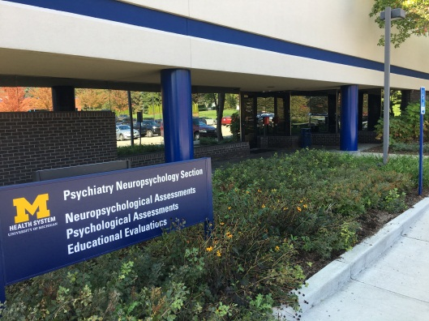**Michigan Medicine Neuropsychology Site**

The Neuropsychology Program, under the direction of Carol Persad, Ph.D., ABPP-CN, has a rich tradition in the measurement of cognitive and behavioral characteristics of diverse patient groups and a close working relationship with other investigators in a number of departments, including Psychiatry, Neurology, Radiology, Pediatrics, Anesthesiology, Oncology, Physical Medicine & Rehabilitation, Surgery, and Internal Medicine, as well as other Medical Center programs and other University units, such as the schools of Nursing, Public Health, and Engineering and the Institute of Social Research. The Neuropsychology Program plays an integral role in many clinical research studies and clinical trials. The Program evaluates more than 3000 patients annually based on referrals for neuropsychological sequelae associated with general medical and neurological conditions, dementia, pre-surgical evaluations, mood disorders, and neurodevelopmental and learning/attention problems. The program also completes numerous research-based evaluations for investigators in the Neuropsychology Program and Department of Psychiatry, as well as for researchers throughout the medical center and through contracts with industry. In response to the COVID-19 pandemic, the Neuropsychology Program has initiated empirically-supported Teleneuropsychology services, which are offered in combination with hybrid and in-person services, based on specific patient needs. Faculty, postdoctoral residents, and staff are involved in the development and evaluation of these services through programmatic research.

***Michigan Medicine Facilities***

The Michigan Medicine Neuropsychology Program is housed in over 3,000 square feet at the Commonwealth Building located between the main medical center and the East Ann Arbor medical campus. The Michigan Medicine Program currently includes 17 faculty members (8 Board Certified in Clinical Neuropsychology), 13 masters level psychologists, 7 postdoctoral residents, research assistants, and other students and trainees. Our facility is equipped with modern psychological test instruments and computers for measurement of psychological and psychophysiological behaviors, including the latest computer-based testing devices. The laboratory facility includes sets of adjacent rooms separated by a one-way mirror for patient observation and video and sound equipment for patient monitoring, a large research area for mobility and driving simulator studies, a computer laboratory for imaging studies, and three conference rooms equipped with video-conferencing capabilities. Fourteen testing rooms are housed at Michigan Medicine, along with other open laboratory space and faculty, trainee, and staff offices. Permanent satellite evaluation rooms are also located at the inpatient psychiatric unit at University Hospital, Rachel Upjohn Building / Ambulatory Psychiatry, the Michigan Clinical Research Unit, and the Michigan Medicine Med Inn. The Michigan Alzheimer’s Disease Research Center (MADRC) is also located in the Commonwealth Building and shares many of the Neuropsychology Program facilities and research space. All postdoctoral residents have individual offices with desktop computers at the Commonwealth Building.

**VAAAHS Neuropsychology Site**

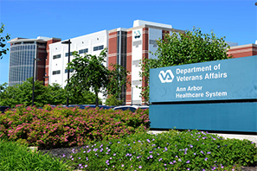The VAAAHS Neuropsychology Section has a long history of evaluating Veterans in acute and long-term care inpatient settings, outpatient clinics, and rehabilitation units. The Section has a major role in the diagnosis and evaluation of medical, neurological, and psychiatric conditions which affect cognitive and personality changes. The Section is widely integrated into research investigating the interaction between medical disease and injury, cognitive and personality changes in Veterans, and the early detection and non-pharmacologic treatment of cognitive and behavioral impairment. In recent years this research has included studies of the effects of test validation, rehabilitation outcomes, and the role of motivation in neuropsychological test performance, and interactive effects of PTSD and mild head injury. Additional ongoing federally-funded studies investigate the behavioral and neuroanatomical impact of cognitively oriented treatments (e.g., cognitive rehabilitation, cognitive training) and non-invasive brain stimulation in older adults with cognitive impairment, using novel neuroimaging modalities. The VAAAHS currently employs four post-doctoral residents in Clinical Neuropsychology.

***VAAAHS Facilities***

VA Ann Arbor Hospital is a general medical and surgical hospital in Ann Arbor, MI, with 142 beds, serving Veterans from Southeastern Michigan and Northern Ohio.  It is accredited by the Commission on Accreditation of Rehabilitation Facilities (CARF). It provides the full range of inpatient and outpatient services, including neurology, neurosurgery, and geriatric internal medicine in addition to other medical and surgical services. Facilities are newly updated in most areas, including Mental Health, Outpatient, and Nursing Home facilities. Offices for neuropsychology residents are at our Packard Road location with modern support facilities, full computer access to the Michigan Medicine information systems and library, as well as VAAAHS information systems.

Unique patients in fiscal year (FY) 2019 (FY19) were 69,686 with over 610,000 outpatient visits. Now an estimated 7.5% of VA care is for female Veterans nationally, with the number steadily growing. The representation of women in the Afghanistan-Iraq (OEF/OIF) veteran cohort is dramatically greater than for any previous conflict. There is predominance of Vietnam-era Veterans by era of service, but 26% of our unique patients are age 54 or younger. Facility Aggregate Reports through the 4th Quarter of FY18 show VAAAHS as ranking high among high complexity facilities in combined quality domains of access, clinical performance, and patient satisfaction.

**Education**

Residents in the Michigan Medicine/VAAAHS Consortium in Clinical Neuropsychology have several unique learning opportunities, ranging from targeted coursework to visiting lectures. Educational offerings include both mandatory training requirements to ensure consistent progress through the training program, and optional training opportunities that can be pursued to enrich the training experience to the extent that time is available.

***Required*:**

* Didactic and Journal Club (weekly): This offering is a mix of didactic training and case conferences with a fact-finding format; Sample topics have included Movement Disorders, Degenerative Conditions, Multiple Sclerosis, Epilepsy/Wada, Pediatric Neuroimaging, Cerebrovascular Disease, Toxin Exposure, Developmental disorders (i.e., ADHD, LD), Aphasias, and more.
* Michigan Alzheimer’s Disease Research (MADRC) Center Clinical Pathological Correlation (four times per year): This seminar integrates the neurological examination, clinical presentation, neuropsychological test results, and post-mortem histopathological findings of participants seen in the MADRC. When offered, this conference takes the place of Journal Club for the week.
* Professional Development Seminar (weekly for first year residents; monthly for second year residents): This seminar is designed to increase interaction with psychology postdocs outside the neuropsychology section and provide lectures on topics ranging from legal/ethical issues, negotiating a job, giving a job talk, private/forensic practice, and work/life balance.
* Grand Rounds in Psychiatry and/or Neurology (weekly): Residents can choose from neurology or psychiatry rounds each week. If a regularly scheduled educational offering more closely matches a resident’s interests and career goals, these can instead be incorporated into the training plan with permission.
* Staff Meeting (weekly at Michigan Medicine; monthly at VAAAHS)
* Bioethics Conference (twice per year)

***Optional opportunities in accordance with training goals and as time permits*:**

* Neuroanatomy lecture and wet lab (audited class taken through University of Michigan Graduate School; first semester of second year of program): This class provides training in neuroanatomy and “hands-on” experience designed to improve the understanding of brain-behavior relationships and to provide preparation for the clinical neuropsychology written board examination.
* Cross-cultural seminar (monthly for second year residents): This seminar is primarily done in case conference format, and includes video participation from Aristotle University of Thessaloniki, Greece, Chukwuemeka Odumegwu Ojukwu University – Igbariam Campus in Nigeria, Makarere University in Uganda, Michigan State University in Lansing, MI, Vytautas Magnus University in Lithuania, and the Norwegian University of Science and Technology.
* Test Practicum: Weekly offering at the VAAAHS addressing neuropsychology test-specific topics including test administration, scoring, normative comparisons, and reliability and validity.
* Weekly VAAAHS Case Conference: This conference is in conjunction with the Clinical Psychology Internship Program at the VA Healthcare System
* Neuropathology Conference (Brain cuttings)
* Neuroimaging Meetings / Neuroradiological Conference
* Refractory Epilepsy Conference
* Michigan Alzheimer’s Disease Research Center’s Consensus Conference (biweekly multi-disciplinary diagnostic meeting)
* Department specific conferences (Surgery, Psychiatry/Depression Center, Internal Medicine, Cardiology, Radiology, Oncology, and Institute of Gerontology)
* VAAAHS Geriatric Research Education and Clinical Center (GRECC): This meeting includes an interdisciplinary clinical case conference and GRECC research conference
* Diversity, Equity, and Inclusion Opportunities
  + *Psychiatry Department Diversity, Equity, and Inclusion Series*: This series includes monthly “Lunch and Learns”. Recent examples include Working with Transgender People Across the Lifespan, COVID-19 Disparities and Underlying Causes, The Impacts of Race on Psychological Wellbeing, Cultural Humility, Discussion of Disability/Ability, Ways to Be a Better Ally in the Workplace, etc. When possible, these offerings take the place of part of MM Journal Club for the week.
  + *Psychiatry Department and Neuropsychology Section DEI committees:* Several workgroups have been developed including those that focus on (1) Clinical work, (2) Research, (3) Education, (4) Workplace Environment, and (5) Community Outreach
  + *Psychiatry DEI Retreat*: Annual offering through the Psychiatry department
  + *DEI Certificate Program:* This program is open to University of Michigan graduate students and postdoctoral fellows and is designed to prepare individuals to work in diverse environments while fostering a climate of inclusivity.

**Teaching / Supervision Experiences**

Residents have the opportunity to perform tiered clinical supervision of pre-doctoral practicum students and interns. Additional supervision of undergraduate students who work with faculty and residents on a wide variety of research projects is also available. In addition, residents may also assist in teaching seminars with faculty members or teaching lectures to current medical students and residents.

**Adult Neuropsychology - Clinical Training Experiences**

**Clinical training experiences comprise approximately 50% of the resident’s time**

***Michigan Medicine***

General Neuropsychology Clinic**:** Adult neuropsychology residents conduct four outpatient evaluations per week for adult and geriatric patients with a wide array of presenting cognitive, emotional, and behavioral conditions. A psychometrist model is used for the majority of assessments, with the resident responsible for interviewing, interpreting data, writing clinical reports, and providing feedback. Throughout training, residents demonstrate psychological assessment and interview skills by completing neuropsychological screens of patients being considered for bariatric surgery. Residents may also see cases from geriatric psychiatry that primarily involve differentiating neurodegenerative diseases from psychological disorders. Services are provided in-person, via virtual (video/phone), or hybrid modalities.   
  
Postdoctoral residents regularly staff interdisciplinary clinics with medical residents and attending staff. Required experiences for Michigan Medicine residents include Cognitive Disorders Clinic and Epilepsy Clinic. Additionally, all Michigan Medicine residents complete a 4-month rotation that involves assessment of pediatric patients. These clinic experiences include integration of neuropsychological assessment data with neurological and medical evaluations and discussion of the case along with teaching by attending staff.  
  
Primary Clinic Experiences**:**

*Cognitive Disorders Clinic***:** This weekly clinic in neurology evaluates cognitive difficulties that can occur with aging. It provides diagnosis and comprehensive management of patients with memory loss and disorders of higher cognitive function and dementia. Neuropsychology residents observe neurological examinations and provide consultation about patients’ neuropsychological evaluation to the treatment team.

*Epilepsy Program***:** The University of Michigan Adult and Pediatric Epilepsy Neuropsychology Programs are in a collaborative within the Department of Neurology and Department of Neurosurgery and are recognized by the National Association of Epilepsy Centers (NAEC) as a Level 4 Certified Epilepsy Center, the highest certification available from the NAEC. Both adult and pediatric programs see patients for treatment of epilepsy, and in cases where treatments have failed, patients are evaluated for consideration of surgical relief of their seizure disorder. Each patient under consideration for surgery participates in a thorough evaluation in the Comprehensive Epilepsy Program, which includes EEGs, brain imaging (MRI, PET, SPECT), speech and language assessment, social work, neuropsychological evaluation, and potentially Wada and fMRI procedures. Approximately 70-100 epilepsy surgeries are conducted per year. This rotation follows a lifespan model and has the following aims: 1) Pre-surgical neuropsychological evaluation to assess functional brain status, assist in the lateralization and localization of seizure focus, assess for any psychiatric issues, and establish a baseline, 2) Assess language lateralization and unilateral memory functions following an injection of Brevital (Wada Procedure), and 3) Post-surgical neuropsychological evaluation to evaluate change over time and provide recommendations. Residents on this rotation will also attend the weekly multidisciplinary Refractory Epilepsy Conference.

*Pediatric Clinics***:** To ensure lifespan training, adult residents will complete a 4-month rotation conducting pediatric assessments. During this rotation, they will conduct outpatient evaluations for children and adolescents with a wide array of presenting cognitive and behavioral challenges including neurodevelopmental disorders such as ADHD and autism spectrum disorder, as well as epilepsy, congenital heart disease, hematological/oncological conditions, and genetic syndromes. They may also participate in the ASD and ADHD multidisciplinary clinics. These outpatient clinics are responsible for the diagnosis and treatment of children with suspected autism spectrum disorders and attention-deficit/hyperactivity disorder as well as common psychiatric comorbidities. Observational opportunities may also be available in the Epilepsy, General Neurology, and the Hematology/Oncology Clinics.

Optional Clinic Experiences**:** Residents have the opportunity to gain experience in other Neuropsychology Program-supported clinics, including the Neurosport Clinic, the Movement Disorder Clinic, and several clinics at the VAAAHS (e.g., Community Living Center, Polytrauma/TBI Clinic, Substance Abuse Clinic, Post Traumatic Clinic).

***VA Ann Arbor Healthcare System***

General Neuropsychology Clinic**:** Services are provided throughout the hospital and on the outpatient service. Referrals vary from assessment for cognitive change related to conditions such as epilepsy, head trauma, substance abuse, neurodegenerative diseases, chronic health conditions, and psychiatric disorders. Referral sources include Ambulatory Medicine, Psychiatry, and Neurology services. Residents are responsible for selecting and administering neuropsychological tests, interviewing, interpreting, writing clinical reports, providing feedback, and consulting with referring providers. Over the two-year training period, residents typically progress from primarily testing their own cases to a mixture of psychometrist and self-administered evaluations. Second year residents are also actively involved in pre/post deep brain stimulation (DBS) evaluations.

Primary Clinic Experiences**:** Some experiences are only available to second year residents.

*VAAAHS Polytrauma Clinic***:** This clinic primarily evaluates Veterans returning from recent theatres of action in the Middle East as well as other areas of conflict. Among more common questions for referral are concerns about cognitive and emotional effects of mild head injury, cognitive and affective correlates of post-traumatic stress disorder, and cognitive and personality changes associated with other sources of service-related physical and emotional traumas. Residents provide consultation-liaison services within the clinic, working closely with Physical Medicine & Rehabilitation, social work, and speech and language providers to deliver brief screenings of cognitive performance and symptom validity, as well as full evaluations for appropriate cases. Residents may also have the opportunity to provide psychoeducation regarding head injury to patients and their caregivers and to follow Polytrauma Clinic veterans in individual therapy. Clinic data are also available for frequent use in related institution-approved research projects.

*Geriatric Medicine Clinic****:*** The neuropsychology service is integrated into the VAAAHS Geriatric Medicine Clinic, with the goal of providing accessible, timely, and coordinated assessment and intervention services to patients in an interdisciplinary framework. The resident is present in the clinic one day per week and provides assessment and intervention services, along with general consultation to Geriatric Medicine residents, fellows, and attending physicians. Assessment opportunities consist of cognitive screening and rapid neuropsychological assessment with same-day feedback to the veteran and medical team. Brief behavioral interventions are also available.

*Community Living Center (CLC):* In the CLC, residents gain exposure to assessment and intervention services for (generally) older adults admitted to a post-acute rehabilitation unit known as the Community Living Center. CLC veterans are generally admitted for specific functional needs, often in the context of deconditioning, medical management (e.g., antibiotic treatment, cancer treatment, wound healing), along with other cardiac, pulmonary, or neurologic conditions. The resident will complete brief cognitive/behavioral health screens and focused neuropsychological assessments that meaningfully contribute to the Veteran’s rehabilitation and discharge planning. Residents may gain exposure to acute presentations (e.g., delirium, post-intensive care syndrome), and other neurologic and rehabilitation samples (e.g., TBI, stroke). Intervention opportunities are also available, specifically with brief therapy and interventions focused on health behavior change (e.g., smoking cessation, engagement or adherence to rehabilitation recommendations, adjustment to medical illness). Further clinical opportunities may also include consult-liaison assessment/intervention throughout the hospital. Residents are also encouraged to attend a weekly geriatric and rehabilitation didactic when available.

Optional Training Experiences:

*Michigan Alzheimer’s Disease Center (MADC):* The MADC is one of 33 Centers funded by the National Institute on Aging to study age- and disease-related cognitive and functional decline. Residents have the option of seeing patients clinically as a part of the MADC’s flagship study known as the University of Michigan Memory in Aging Project (UM-MAP). This study collects annual neurological and neuropsychological data on a cohort of about 400 participants who span the dementia spectrum (i.e., from “normal” cognition to advanced dementia of various etiologies). An increasing number of UM-MAP participants also have biomarker data including blood, genetics, MRI (structural and functional), and PET (amyloid and tau ligands). Residents can gain additional assessment experience with UM-MAP participants, participate in and lead the bimonthly diagnostic consensus conference, provide feedback to participants and their families, and perform research studies using MADC infrastructure.

Other experiences include the Substance Abuse Clinic and Post Traumatic Clinic, and several clinics at Michigan Medicine (e.g., Cognitive Disorders Clinic, Movement Disorder Clinic, Epilepsy/Wada Clinic, Neurosport Clinic, ADHD Clinic, and ASD Clinic).

**Adult Neuropsychology – Research Experiences**

Applicants with strong research interests are encouraged to apply, as residents are expected to participate in the development and execution of research in collaboration with neuropsychology faculty. Residents will be selected according to program availability and their research areas of interest to focus in the following areas of research:

***Michigan Medicine***

*Adult Neuromedical: (1 Position Available for 2022)*

The Neuropsychology Program has strong ties with many departments in the Medical School including Neurology, Neurosurgery, Oncology, Psychiatry, Cardiology and Obstetrics/Gynecology. The Neuromedical research emphasis is on interdisciplinary research with a translational focus. The opportunities for training will be based upon interest and available research projects at the time of residency.

Below is a sample of research projects that are currently ongoing:

* In collaboration with the Departments of Neurology and Neurosurgery, research is investigating the cognitive correlates of **epilepsy and outcomes of surgery**. Research is led by David Marshall, Ph.D., ABPP-CN and Elise Hodges, Ph.D.
* In conjunction with the Departments of Oncology and Internal Medicine, research is exploring the longitudinal cognitive and psychological changes associated with **bone marrow transplant** in order to tailor treatment planning and identify risk factors associated with cognitive decline. This work includes clinical trial investigations of various therapeutic agents, outcomes associated with differing treatment modalities, and effect of nutrition and fitness on improvement after cancer. Research is led by Kristen Votruba, Ph.D., ABPP-CN.
* As part of the UM STIM Program (Surgical Therapies to Improve Movement), research to develop models to improve successful outcomes and identify risk of cognitive or functional declines after **Deep Brain Stimulation** in patients with Movement Disorders. Research is led by Carol Persad, Ph.D., ABPP-CN.
* In collaboration with the Departments of Neurology and Internal Medicine, the Neuropsychology Program is conducting evaluations of patients with **metabolic syndrome and obesity** prior to and throughout the course of different treatment approaches in order to better understand cognitive and behavioral change in these patients over time. Research is led by Kristen Votruba, Ph.D., ABPP-CN.
* In collaboration with Psychiatry research programs, specifically the Heinz C. Prechter Bipolar Research Program (<https://medicine.umich.edu/dept/prechter-program>), the Michigan Social Cognitive and Affective Neuroscience Lab (https://tso.lab.medicine.umich.edu/home), and the Program for Risk Evaluation and Prevention (<https://prep-psychosis.medicine.umich.edu/home>), we offer research opportunities that focus on the clinical neuropsychology of **serious mental illness,** **including schizophrenia, bipolar disorder, and other mood and psychotic disorders**. The resident will have access to a large longitudinal bipolar database and multiple extant datasets to pursue their own research themes of interest. Data available include neuropsychology topics related to health/medical comorbidities, psychiatric comorbidities, well-being, sleep, trauma, inflammatory markers, cognitive trajectories, and using novel-technologies to capture real-time assessments of mood and cognition. Additional areas include use of brain stimulation (tDCS and TMS) and computerized cognitive training to improve cognitive functioning in SMI, as well as use of behavioral, electrophysiological, neuroimaging, and computational methods to better understand the neural basis of SMI. Primary mentors are Cynthia Burton, Ph.D., David Marshall, Ph.D., ABPP-CN and Kelly Ryan, Ph.D., ABPP-CN.
* In conjunction with Ob/Gyn and Psychiatry, research is underway to understand cognitive and neuroactivation changes associated with **estrogen replacement therapy (ERT)** in peri- and post-menopausal women. Neuropsychological outcomes, PET and fMRI data are combined to assess risks and benefits of ERT in this population. Research is led by Carol Persad, Ph.D., ABPP-CN.
* Since the COVID-19 pandemic, faculty, staff, and residents have created a task force to collect data and develop projects related to the feasibility and validation of **Teleneuropsychology (TeleNP**). Current projects include evaluations of the impact of TeleNP on diagnostic decision-making and confidence, patient perceptions of TeleNP, and a national survey of TeleNP and decision-making among neuropsychologists. Research is led by Annalise Rahman-Filipiak, Ph.D.

*Geriatric/Dementia: (1 Position Available for 2022)*

The Neuropsychology Section maintains a strong research program related to the early identification of neurodegenerative disorders. The program is closely related to the Michigan Alzheimer’s Disease Center (MADC) housed in the same building as the Neuropsychology Section. The MADC aims to:  a) conduct and promote research on Alzheimer’s disease and related disorders; b) enhance the clinical care of patients and families affected by Alzheimer’s disease and related dementias; and c) provide information and education on Alzheimer’s disease and related disorders. In close collaboration with the MADC, the Neuropsychology Section conducts innovative memory and aging research to enhance our understanding of a) biomarkers used for early detection; b) disease modifying treatments; c) basic disease mechanisms in AD and other dementias; and d) effective strategies to help individuals with memory loss and their families. Several large databases provide numerous opportunities for research and provide well characterized data for postdoctoral resident and faculty-initiated research projects. Recent and ongoing projects in the Neuropsychology Section include:

* Comparisons of healthy controls, MCI, Alzheimer’s, and other dementias on:
* Techniques to enhance driving using the Section’s driving simulator
* Simple and complex walking conditions involving increasing cognitive load using the Section’s Mobility Laboratory
* The relationship of neuropsychological performance and positron emission tomography measures
* Caregiver burden and service utilization
* The utility of neuroimaging, ERP measures, and computer-based neuropsychological screening in the early identification of cognitive difficulties in community dwelling African Americans.
* The effects of cognitively oriented treatments (e.g., Cognitive Rehabilitation, Cognitive training) and/or non-invasive brain stimulation on cognition and functional connectivity in older adults.
* Alzheimer’s Disease biomarker identification and risk communication.
* Health behavior change following diagnostic feedback and/or biomarker disclosure in racially diverse older adults and their families.

Residents also participate regularly in scholarly publication related to aging-related topics such as healthy cognitive aging, differences in age of onset and prognosis of neurological and psychiatric disorders, and the interaction between cognitive and psychological change in older individuals. Research in aging / geriatrics is led by Linas Bieliauskas, Ph.D., ABPP, Bruno Giordani, Ph.D., Benjamin M. Hampstead, Ph.D., ABPP-CN, Annalise-Rahman-Filipiak, Ph.D., Amanda Maher, Ph.D., and Anson Kairys, Ph.D. with additional projects led by other faculty members.

***VA Ann Arbor Healthcare System***

*Adult/Geriatric Neuropsychology: (2 Positions Available for 2022)*

Academic track:

Residents can participate in ongoing federally funded research studying the effects of cognitively oriented treatments (e.g., Cognitive Rehabilitation, Cognitive training) and/or non-invasive brain stimulation on cognition and functional connectivity in older adults across the dementia spectrum. Residents will have access to a growing database of neuropsychological and neuroimaging data (both structural and functional MRI; amyloid and tau PET data collection began in Fall 2018). Opportunities for both prospective and retrospective neuromodulation and neuroimaging work are available and will be developed based on mutual interests. Residents will be expected to present research at national or international meetings and to publish study results. The primary supervisor is Benjamin M. Hampstead, Ph.D., ABPP-CN.

Generalist track:

Residents can participate in neuropsychological research that is more general in nature. In recent years, this has included studies evaluating factors predicting cognitive performance in polytrauma, psychometrics, and sleep. Specifically, studies have broadly focused on measurement theory, performance/symptom validity, and psychological testing. Primary supervisors include Robert Spencer, Ph.D., Michael Ransom, Ph.D., Ben Hampstead, Ph.D, ABPP-Cn, and Andrew Hale, Ph.D.

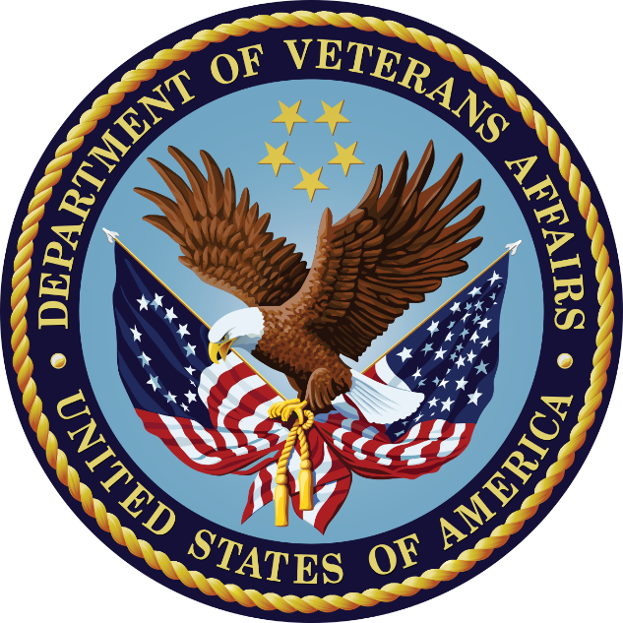

**Pediatric Neuropsychology - Clinical Training Experiences**

General Neuropsychology Clinic:The Pediatric Neuropsychology resident conducts outpatient evaluations for children and adolescents with a wide array of presenting cognitive and behavioral challenges. The most common referrals include epilepsy, congenital heart disease, hematological/oncological conditions, genetic syndromes, as well as neurodevelopmental disorders such as ADHD and autism spectrum disorder. A psychometrist model is used for the majority of the assessments, with the resident responsible for interviewing, interpreting, writing clinical reports, and providing feedback. Residents also provide inpatient consultation services on a rotating basis with adolescents and adults who are typically receiving inpatient psychiatric care. One of the goals of this program is to ensure that all residents gain experience with patients across the entire lifespan. As such, all Michigan Medicine residents will complete a 4-month experience that involves assessment of adult and geriatric patients.

Postdoctoral residents staff interdisciplinary clinics with medical residents and attending providers. Experiences for pediatric residents are offered in Autism Spectrum Disorder Clinic, Multidisciplinary Developmental Evaluation Clinic, Epilepsy Clinic, General Neurology Clinic, and Hematology/Oncology Long Term Follow-Up Clinic. Experiences include integration of neuropsychological assessment data with a patient’s neurological and medical evaluations and discussion of cases with providers from multiple disciplines.

Primary Clinic Experiences**:**

*ASD Clinic***:** This weekly clinic conducts diagnostic evaluations of children and adolescents ages 5 and older with autistic spectrum disorders (ASD) as well as comorbid psychiatric and behavioral disorders. Assessments follow a comprehensive multi-disciplinary team approach consisting of a neuropsychological evaluation, social work assessment, speech and language evaluation, and full medical/psychiatric examination. Please note, due to the COVID pandemic, this clinic is currently conducted virtually.

*Multidisciplinary Developmental Evaluation Clinic (MDEC):*This weekly clinic conducts diagnostic evaluations of children ages five and under with developmental concerns, including autism spectrum disorders (ASD). Assessments follow a multi-disciplinary team approach consisting of clinical interview and play observation with neuropsychology, speech and language evaluation, and medical/neurological examination. Some patients are referred for further comprehensive developmental evaluation including ADOS-2 or BOSA within the neuropsychology section.

*Hematology/Oncology Clinic:*Residents may participate in the weekly pediatric hematology/oncology Long Term Follow-Up clinic for children and young adults who are survivors of childhood cancer (e.g. leukemia, lymphoma, solid tumors). The neuropsychologist provides brief consultation with the patient in conjunction with the team educational specialist to review educational and cognitive concerns and provide input regarding need for neuropsychological evaluation and/or follow-up on results from recently completed neuropsychological evaluation if available.

*Epilepsy Clinic:* Residents may participate in the weekly epilepsy conference for pre-and post-surgical consultation. The multidisciplinary team consists of neuropsychology, neurosurgery, neuroradiology, social work, and speech and language pathology. Opportunities for observation of Wada testing are also available.

*General Neurology Clinic:* Residents may participate in a weekly pediatric neurology clinic to observe neurological examination and treatment of a variety of neurological disorders (i.e. headaches, seizure disorder, global developmental delay, neuromuscular disorders).

**Pediatric Neuropsychology – Research Experiences**

*Pediatric Neuropsychology: (1 Position Available for 2022)*

Applicants with strong research interests are encouraged to apply, as the resident is expected to participate in the development and execution of research in collaboration with the pediatric neuropsychology faculty. Current research in the division involves multidisciplinary projects focused on autism spectrum disorder, oncology, cardiology, and sleep disordered breathing in children. Primary research mentors are Kimberley Heinrich, Ph.D. ([heinrikp@med.umich.edu](mailto:heinrikp@med.umich.edu)), Elise Hodges, Ph.D. ([ekhodges@med.umich.edu](mailto:ekhodges@med.umich.edu)), Annette Richard, Ph.D., ABPP-CN ([annricha@med.umich.edu](mailto:annricha@med.umich.edu)), and Kaitlin Oswald, Ph.D. (kaitliao@med.umich.edu), as well as support from Bruno Giordani, Ph.D., and Carol Persad, Ph.D., ABPP-CN. Interested applicants are encouraged to contact Drs. Heinrich, Hodges, Richard, and Oswald for more specific information. Below is a sample of research projects that are currently ongoing:

* Neuropsychological profiles of pediatric pre- and post-surgical **epilepsy** patients via Pediatric Epilepsy Research Consortium (PERC; https://pediatricerc.com. Primary pediatric research mentor on this project is Elise Hodges, PhD.
* Neurodevelopmental outcome of children with a history of **congenital heart disease**. Projects are being conducted in collaboration with the Congenital Heart Center Neurodevelopmental Follow-Up Clinic, which includes Pediatric Cardiology and Pediatric Psychology. Primary research mentor is Kimberley Heinrich, Ph.D. with additional mentorship provided by Elise Hodges, Ph.D., Bruno Giordani, Ph.D., and Carol Persad, Ph.D., ABPP-CN.
* Neurodevelopmental outcomes of intensive **speech therapy intervention** in children with ASD. Primary research mentor is Annette Richard, Ph.D., ABPP-CN
* Predictors and impacts of **education service disparities** in the context of the COVID-19 pandemic. Primary mentor is Annette Richard, Ph.D., ABPP-CN.
* Neurocognitive outcomes in survivors of **pediatric cancer**, as well as specifically examining the relationship between cognition and health behaviors (e.g., sleep, physical activity) in survivors and optimal cognitive screening methods in pediatric oncology. Primary pediatric research mentor on this project is Kaitlin Oswald, Ph.D.
* **Driving skills** and hazard detection intervention for teens and young adults with autism spectrum disorder. Primary research mentor is Elise Hodges, Ph.D. and Kimberly Heinrich, Ph.D.
* Neuropsychological Profiles of referred pediatric outpatients. We are currently taking advantage of a large dataset examining profiles for children who have been referred for consensus diagnosis of ADHD and ASD, as well as epilepsy, pediatric cancer, congenital heart disease, and learning disorders. We are particularly interested in neuropsychological profiles in these groups as well as influential covariates. Primary mentors on this project are Elise Hodges, Ph.D., Kimberley Heinrich Ph.D., and Annette Richard, Ph.D., ABPP-CN.

**Current Residents**

*Residents beginning their Residency in 2020*

* Elizabeth Campbell, Psy.D.:VAAAHS: Wright State University (Psy.D), Veterans Affairs Palo Alto Health Care System (Internship)
* Anthony Correro, Ph.D.: VAAAHS; Marquette University (Ph.D.), VA Boston Healthcare System (Internship)
* Tobin Ehrlich, Ph.D.: Michigan Medicine Mood Disorders; Palo Alto University (Ph.D.), Central Texas Veterans Health Care System (Internship)
* Taylor Greif, Ph.D.: Michigan Medicine - Neuromedical; Saint Louis University (Ph.D.); University of Oklahoma Health Sciences Center (OUHSC) / Oklahoma City VA Consortium (Internship)
* Lindsay Katz, Psy.D.: Michigan Medicine Pediatric Neuropsychology; Roosevelt University (Psy.D.); AMITA Health Alexian Brothers Women and Children’s Hospital (Internship)

*Residents beginning their Residency in 2021*

* Brandon Almy, Ph.D.: Michigan Medicine Pediatric Neuropsychology; University of Minnesota (Ph.D.), University of Minnesota Twin Cities (Internship)
* Jessica Bair, Ph.D.: VAAAHS; University of Minnesota (Ph.D.), VA Ann Arbor Healthcare System (Internship)
* David Brush, Ph.D.: Michigan Medicine - Geriatrics; University of Central Florida (Ph.D.); University of Alabama Birmingham-Birmingham VA Medical Center Consortium (Internship)
* Sam Crowley, Ph.D.: VAAAHS; University of Florida (Ph.D.), Emory University (Internship)
* Ellen Johnson, Ph.D.: Michigan Medicine Neuromedical; Ohio University (Ph.D.); Missouri Health Sciences (Internship)
* Taylor Rigby, Ph.D.: Michigan Medicine - Geriatrics; University of Kansas (Ph.D.); VA Eastern Kansas Health Care System (Internship)

**Neuropsychology Consortium Training Directors**

**Michigan Medicine**

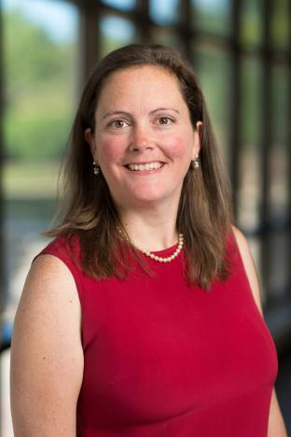

**Kristen Votruba, Ph.D., ABPP-CN,** Clinical Associate Professor in the Neuropsychology Program, Department of Psychiatry; Neuropsychology Training Director at Michigan Medicine. Dr. Votruba completed her undergraduate degree in biopsychology at the University of Michigan and earned her Ph.D. in clinical psychology with a focus in neuropsychology from Wayne State University. She completed an American Psychological Association (APA) accredited internship in clinical psychology (neuropsychology track) at the Ann Arbor Veterans Administration, and an APA accredited postdoctoral fellowship in clinical neuropsychology at the University of Michigan. Dr. Votruba's clinical interests include neuropsychological evaluation across the life span, particularly in individuals with neurodegenerative disorders, traumatic brain injury, stroke, and cancer. Her primary areas of research include investigating cognitive and psychological outcomes in cancer and obesity. Current funded projects include clinical trials investigating therapeutic agents in cancer that may affect processing speed or memory consolidation, the utility of nutrition and fitness in cancer outcomes, and the effect of obesity and associated medical comorbidities on neurological outcomes.

Email: [kvotruba@umich.edu](mailto:kvotruba@umich.edu)

**Ann Arbor Veterans Administration**

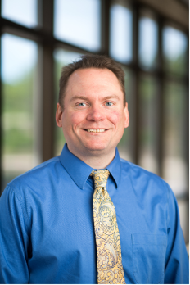**Robert Spencer, Ph.D.,** Chief of the Neuropsychology Section at the Ann Arbor VA. Dr. Spencer completed his doctoral degree in Behavioral Medicine / Clinical Psychology at the University of Maryland, Baltimore County. He completed an APA approved pre-doctoral internship and postdoctoral training in neuropsychology at the Ann Arbor VA. His clinical foci are on neuropsychological assessment, traumatic brain injury, and delivering timely and relevant feedback to patients and providers. His research examines issues related to assessment, traumatic brain injuries, and measurement theory. Email: [Robert.spencer2@va.gov](mailto:Robert.spencer2@va.gov).

**Additional Consortium Principal Training Faculty**

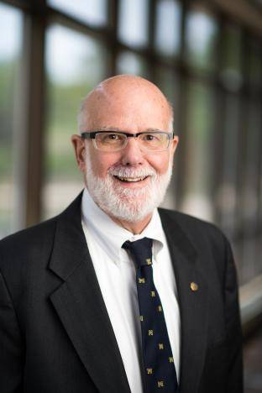**Kenneth Adams, Ph.D., ABPP-CN**, Professor of Psychology, Department of Psychiatry; Professor of Psychology, College of Literature, Science, and the Arts. Dr. Adams completed his undergraduate degree and earned his Ph.D. in psychology from Wayne State University. Internship was completed at Lafayette Clinic (Detroit Medical Center). Dr. Adams’s clinical interests include abnormal aging, long term effects of medical illness on neuropsychological and emotional adaptation, cerebral trauma, and effects of neurotoxic exposures. Research interests include methodology in brain-behavior studies, neuroimaging in studies of neuropsychological issues, long term effects of alcohol and substance abuse, and child neuropsychological risk factors and their effect on adult outcomes. Email: [kmadams@umich.edu](mailto:kmadams@umich.edu).

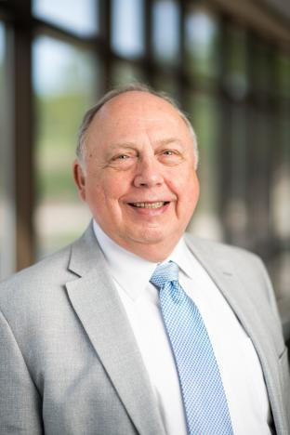**Linas Bieliauskas, Ph.D., ABPP-CN**, Professor of Psychology, Department of Psychiatry; Professor, Department of Psychology. Dr. Bieliauskas completed his undergraduate degree at Xavier University and earned his Ph.D. from Ohio University. Internship was completed at University of Florida. Dr. Bieliauskas’ clinical interests include general neuropsychological evaluation of adult disorders, closed head injury, dementing disorders, and Parkinson disease. His research interests include cognitive and personality changes with normal and abnormal aging, psychometric indicators of cognitive disorders, depression and dementia, neuropsychological predictors of critical life tasks, and cognitive impact of chronic disease. Email: [linas@umich.edu](mailto:linas@umich.edu).

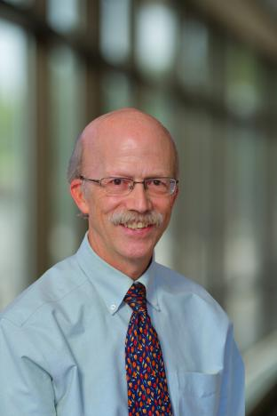**Henry “Gus” Buchtel, Ph.D.**, Associate Professor (Emeritus) in the Neuropsychology Program, Department of Psychiatry. Dr. Buchtel completed his undergraduate degree at Dartmouth College and earned his Ph.D. from McGill University. Clinical interests include epilepsy and epilepsy surgery, dementia, and amnestic disorders. Research interests include brain and behavior relationships, language abilities after anterior temporal lobectomy, attention, consciousness, frontal lobe functions, and brain organization of face recognition. Email: [gusb@umich.edu](mailto:gusb@umich.edu)

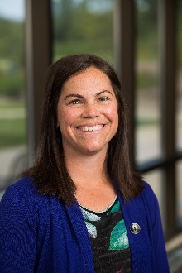**Cynthia Burton, Ph.D.,** Clinical Assistant Professor in the Neuropsychology Program, Department of Psychiatry. Dr. Burton completed her undergraduate degree in psychology at the University of California, San Diego and her Ph.D. in clinical psychology (neuropsychology emphasis) at the SDSU/UCSD Joint Doctoral Program in Clinical Psychology. She completed an APA accredited internship in clinical psychology at the VAAAHS and an APA accredited postdoctoral fellowship in clinical neuropsychology and clinical psychology at the University of Michigan. Dr. Burton’s clinical interests include neuropsychological assessment of adults with neurological and psychiatric disorders, with a particular interest in dementia and severe mental illness (schizophrenia and bipolar disorder). Her primary research interests involve cognitive remediation for individuals with schizophrenia, and improving cognition and everyday functioning among those with mental health conditions. Historically her research has focused on skills training, with more recent expansion to include non-invasive brain stimulation and computerized cognitive training. Email: [czburton@umich.edu](mailto:czburton@umich.edu)

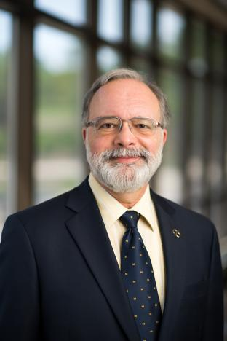**Bruno Giordani, Ph.D.**, Professor (tenured) of Psychiatry, Neurology, and Psychology, and School of Nursing; Chief Psychologist, Department of Psychiatry; Associate Director for the NIH/NIA funded Michigan Alzheimer’s Disease Research Center. Dr. Giordani is a Fellow in Division 40 (Clinical Neuropsychology) and Division 12 (Society of Clinical Psychology) of the American Psychological Association. He completed his undergraduate degree from Dartmouth College and earned his Ph.D. in clinical psychology and psychophysiology from the University of Virginia. He completed an APA accredited internship in clinical psychology and a NIH Training Fellowship in clinical neuropsychology and neuroscience at the University of Virginia and a Health Science Training Fellowship at the University of Michigan and VAAAHS. He completed an APA accredited Postdoctoral Fellowship in Clinical and Research Neuropsychology at the University of Michigan and VAAAHS. Clinical interests include neuropsychological evaluation across the lifespan with emphasis on impairments associated with neurological and medical disorders and sports injuries. Research interests include development of neuropsychological and behavioral assessment techniques in cross-cultural settings including cognitive enhancement through pharmacological and non-pharmacological methods and identification of early cognitive deficits as revealed by neuropsychological, electrophysiological, and neuroimaging modalities. Currently funded research includes studies in imaging, driving, child and adult HIV, validation of computer-based cognitive assessment, early identification of community-dwelling individuals with cognitive decline using electrophysiological and computer-based testing, and studies of cognitive and behavioral factors in hearing loss and cardiovascular disease. Email: [giordani@umich.edu](mailto:giordani@umich.edu)

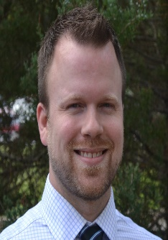**Andrew Hale, Ph.D**. Dr. Hale earned his doctoral degree at Western Michigan University, completed his internship at the Ann Arbor VA, and completed postdoctoral fellowships in research at the VA Center for Clinical Management Research and in Rehabilitation Neuropsychology at Michigan Medicine in the Department of Physical Medicine and Rehabilitation. Additionally, Dr. Hale is a board certified behavior analyst. His clinical interests include the neuropsychological assessment and treatment of traumatic brain injury (TBI) and stroke and the use of Motivational Interviewing, Acceptance and Commitment Therapy, and applied behavior analysis in feedback and rehabilitation settings. Dr. Hale’s research interests include outcomes of TBI and stroke, research and statistical methods for modeling longitudinal change, and development and validation of embedded measures of performance validity. Email: [Andrew.Hale2@VA.gov](mailto:Andrew.Hale2@VA.gov)

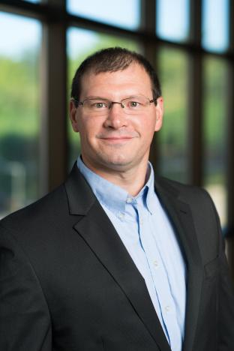**Benjamin Hampstead, Ph.D., ABPP-CN**, Dr. Hampstead is a board-certified Clinical Neuropsychologist who earned his PhD in Clinical Psychology (Neuropsychology emphasis) from Drexel University. He completed his internship and post-doctoral fellowship at Emory University. He is a tenured Professor in Psychiatry at the University of Michigan, Staff Neuropsychologist in the VA Ann Arbor Healthcare System, and both Clinical Core Leader and Neuroimaging Core co-leader of the NIA funded Michigan Alzheimer’s Disease Research Center. Dr. Hampstead’s research focuses on the early detection of cognitive decline arising from aging and neurodegenerative diseases as well as non-pharmacologic approaches to maximize cognitive functioning in older adults. He uses techniques like cognitive rehabilitation and non-invasive brain stimulation to enhance cognition and everyday functioning, typically within the context of a randomized controlled trial. Dr. Hampstead integrates these techniques with functional and structural neuroimaging to predict treatment response, identify neuroplastic changes following treatment, and plan/develop new interventions. This work now includes multiple positron emission tomography (PET) ligands that characterize amyloid and tau as well as cholinergic integrity. Examples of ongoing studies include: 1) the synergistic effects of combined cognitive training and high definition transcranial direct current stimulation (HD-tDCS) in patients with mild cognitive impairment, 2) HD-tDCS dose-response relationships as measured via cognition and functional connectivity in patients with MCI and dementia of the Alzheimer’s type and whether these effects are mediated by biomarker status, 3) targeted neuromodulation of cholinergic functioning in Dementia with Lewy Bodies. Funding has come from, or is currently provided by the Department of Veterans Affairs, National Institute on Aging, National Institute of Mental Health, and the Michigan Alzheimer’s Disease Research Center.

Dr. Hampstead also directs the *Research Program on Cognition and Neuromodulation Based Interventions* (RP-CNBI), the mission of which is to identify and provide effective treatments for those suffering from neurologic injury and disease. The RP-CNBI is uniquely poised to provide tangible next steps for the “what now” question that emerges following neuropsychological assessment. Trainees are able to obtain hands on experience integrating clinical data (neuropsychological, MRI, PET, CSF results) to develop targeted treatment plans that address patient-specific needs. Examples include interventions for cognitive deficits arising from post-anoxic leukoencephalopathy, primary progressive aphasia, posterior cortical atrophy, and Dementia with Lewy Bodies. The RP-CNBI supports a growing list of observational and interventional studies and retains access to hundreds of MRI scans and associated neuropsychological data.

Email: [bhampste@med.umich.edu](mailto:bhampste@med.umich.edu)

Website: <https://hampstead.lab.medicine.umich.edu/home>

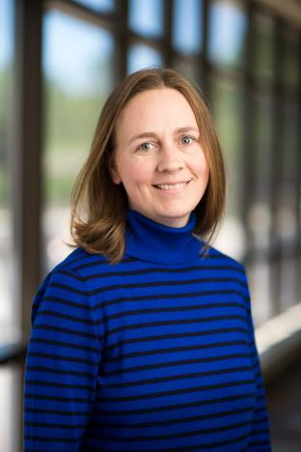**Kimberley Heinrich, Ph.D.**, Clinical Assistant Professor in the Neuropsychology Program, Department of Psychiatry. Dr. Heinrich completed her undergraduate degree in biology and psychology at Michigan State University and earned her Ph.D. in clinical psychology from Central Michigan University. She completed an American Psychological Association (APA) accredited pre-doctoral internship in clinical psychology (neuropsychology track) at University of Florida Health Science Center, and then went on to complete an APA accredited postdoctoral fellowship in clinical neuropsychology at the University of Michigan. Dr. Heinrich’s clinical interests include neuropsychological and psychological evaluation in pediatric populations, particularly in children with neurodevelopmental disorders, cancer, and congenital heart disease. Her primary areas of research include investigating neurodevelopmental outcome in children with a history of congenital heart disease as well as neuropsychological sequelae of pediatric cancer.. She is also interested in investigating neuropsychological and psychosocial outcomes of children with developmental disorders. Email: [heinrikp@umich.edu](mailto:heinrikp@umich.edu)

**Elise Hodges, Ph.D.**, Clinical Associate Professor in the Neuropsychology Program, Department of Psychiatry; Clinical Director of the Neuropsychology Program. Dr. Hodges completed her undergraduate degree in psychology at the University of Michigan and earned her Ph.D. in clinical psychology with a neuropsychology specialty from Wayne State University. She completed an American Psychological Association (APA) accredited pre-doctoral internship in clinical psychology at the Ann Arbor Veteran’s Administration Healthcare System and then completed an APA accredited postdoctoral fellowship in pediatric clinical neuropsychology at the University of Michigan. Clinical interests include pediatric, adolescent, and adult neuropsychological assessment, epilepsy, driving skills, transition to adulthood, and neuropsychological sequelae of medical conditions across the lifespan. Email: [ekhodges@umich.edu](mailto:ekhodges@umich.edu)

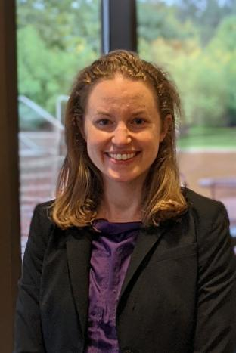**Amanda Cook Maher, Ph.D.**, Clinical Assistant Professor, Neuropsychology Program, Department of Psychiatry. Dr. Maher completed her undergraduate degree in neuroscience at Middlebury College in Middlebury, VT and earned her Ph.D. in clinical psychology with a focus in neuropsychology at Northwestern University Feinberg School of Medicine. She completed an APA accredited internship in clinical psychology (neuropsychology track) at Emory University School of Medicine, and an APA accredited post-doctoral fellowship in neuropsychology at the University of Michigan. Dr. Maher’s clinical interests include the neuropsychological evaluation of older adults, with a particular interest in neurodegenerative disease. Her research interests include successful cognitive aging (e.g., ‘SuperAgers’), early detection of Alzheimer’s disease and related disorders, and investigation of interventions that may minimize cognitive decline.

Email: [amhco@med.umich.edu](mailto:amhco@med.umich.edu)

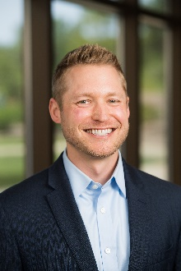**David Marshall, Ph.D.**, **ABPP-CN,** Clinical Assistant Professor in the Neuropsychology Program, Department of Psychiatry. Dr. Marshall completed his undergraduate degree at Michigan State University and earned his Ph.D. in clinical psychology with a neuropsychology specialty from the Pacific Graduate School of Psychology at Palo Alto University. He completed an APA accredited internship in clinical psychology (neuropsychology track) at Baylor College of Medicine and an APA accredited postdoctoral fellowship in neuropsychology at the University of Michigan. Dr. Marshall's clinical interests include neuropsychological evaluation in adolescents and adults with neurological and psychiatric disorders. His research interests include investigating features that influence mood disorders as well as cognitive correlates of epilepsy and surgery outcomes. Email: [davimars@med.umich.edu](mailto:davimars@med.umich.edu)

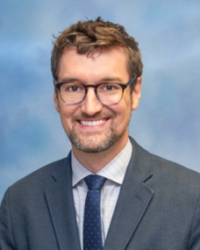**Kyler Mulhauser, Ph.D.**, Clinical Assistant Professor, Neuropsychology Program, Department of Psychiatry. Dr. Mulhauser completed his undergraduate degree in studio art (photography) at Wheaton College (Illinois) and earned his Ph.D. in clinical psychology with a focus in neuropsychology at Saint Louis University. He completed an APA accredited internship in clinical psychology (neuropsychology track) at the University of Alabama-Birmingham and Birmingham VAMC, and an APA accredited post-doctoral fellowship in neuropsychology at the University of Michigan. Dr. Mulhauser’s clinical interests include differential diagnosis of cognitive changes associated with aging and neurodegenerative diseases, characterization of cognitive functioning in adult medical disorders, and evaluation of complex medical cases in which non-credible reporting is suspected. His research interests include executive functioning, impulsivity, and decision making in addiction processes; neuropsychological features predicting clinical outcomes associated with aging and dementia; development and psychometric evaluation of novel performance-based tasks; and improving patient care and optimizing clinical practice in neuropsychology. Email: [mulhause@med.umich.edu](mailto:mulhause@med.umich.edu)

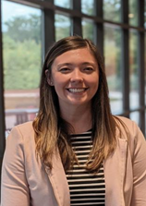**Kaitlin Oswald, Ph.D.,** Clinical Assistant Professor in Neuropsychology Program, Department of Psychiatry. Dr. Oswald completed her undergraduate degree in neuroscience and psychology at Cedar Crest College and earned her Ph.D. in clinical psychology from Eastern Michigan University. She completed an APA accredited internship in clinical psychology at the University of Mississippi Medical Center, and an APA accredited postdoctoral fellowship in pediatric neuropsychology at the University of Michigan. Dr. Oswald's clinical interests include neuropsychological evaluation of pediatric populations, including children with neurodevelopmental disorders and medical conditions including cancer, epilepsy, and congenital heart disease. Primary research areas include examining neurocognitive outcomes in children treated for cancer, specifically the relationship between health behaviors (e.g., sleep, physical activity) and cognitive outcomes. She is also interested in examining the clinical utility and outcomes of neuropsychological services in pediatric populations. Email: [kaitliao@umich.edu](mailto:kaitliao@umich.edu)

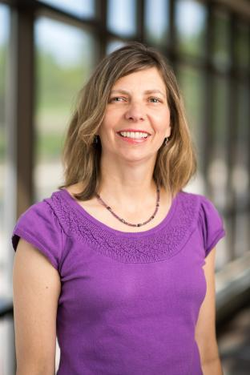**Carol Persad, Ph.D., ABPP-CN**, Clinical Professor, Department of Psychiatry; Director, Neuropsychology Program; Director, University Center for Language and Literacy, Mary A. Rackham Institute. Dr. Persad completed her undergraduate degree in psychology at the University of Toronto and earned her Ph.D. in clinical psychology from Michigan State University. She completed an APA accredited internship at Henry Ford Hospital and a postdoctoral fellowship in clinical neuropsychology at the University of Michigan. Dr. Persad’s clinical practice is across the lifespan with a particular interest in movement disorders and dementia. She is the lead neuropsychologist for the multidisciplinary Deep Brain stimulation program. Her research interests include the cognitive and behavioral impact of deep brain stimulation in Parkinson’s disease, the relationship between cognition and mobility in older adults including how changes in driving behavior may be an early indicator of dementia, and neuroendocrine factors and cognition. Email: [cpersad@umich.edu](mailto:cpersad@umich.edu)

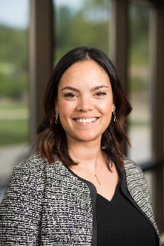**Annalise Rahman-Filipiak, Ph.D.,** Assistant Professor in the Neuropsychology Program, Department of Psychiatry and Michigan Alzheimer’s Disease Center; Faculty in the Clinical Core of the Michigan Alzheimer’s Disease Research Center. Dr. Rahman-Filipiak completed her undergraduate degree in biology, psychology, and neuroscience at the College of Charleston in South Carolina and earned her Ph.D. in clinical psychology from Wayne State University with an additional certificate in Aging & Urban Health from the Wayne State University Institute of Gerontology. She completed an APA accredited internship in clinical psychology (geropsychology / neuropsychology track) and an APA-accredited postdoctoral fellowship in clinical neuropsychology at the Michigan Medicine / VAAAHS Consortium. Dr. Rahman-Filipiak’s clinical interests include neuropsychological evaluation of older adults with Mild Cognitive Impairment and dementias and functional and decision-making capacity assessment. Dr. Rahman-Filipiak currently co-leads the Michigan Brain Health for Aging Independently (BRAIN) Clinic, an interdisciplinary collaboration with the Department of Geriatrics focused on providing rapid assessment and treatment of individuals with suspected mild cognitive impairment. Primary research interests include disclosure of Alzheimer’s disease biomarkers and associated risk for Dementia – Alzheimer’s Type sociocontextual factors predicting disparities in cognitive aging, decisional capacity and neuroethics, and metacognition.

Email:[rahmanam@med.umich.edu](mailto:rahmanam@med.umich.edu).



**Michael Ransom, Ph.D.,** Staff psychologist in theNeuropsychology Section at the Ann Arbor VA. He received his Ph.D. from the University of North Dakota and completed his postdoctoral training in Clinical and Research Neuropsychology at the University of Michigan. His primary clinical interests include the neuropsychology of mood disorders, dementia, traumatic brain injury, and sports concussion. His research activities have focused on cognitive functioning (particularly executive functioning) in individuals with mood disorders, with a focus on

depression. Email: [Michael.Ransom@va.gov](mailto:Michael.Ransom@va.gov)

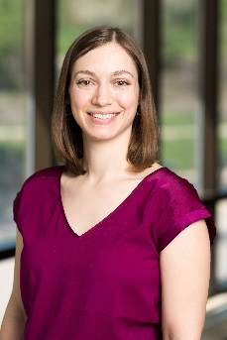**Annette Richard, Ph.D., ABPP-CN,** Clinical Assistant Professor in the Neuropsychology Program, Department of Psychiatry. Dr. Richard completed her undergraduate degree at Dartmouth College and her Ph.D. in clinical psychology from Eastern Michigan University. She completed an APA accredited internship in clinical psychology (pediatric neuropsychology track) at Henry Ford Health System, and an APA accredited postdoctoral fellowship in clinical neuropsychology at the University of Michigan. Dr. Richard’s clinical interests include neuropsychological evaluation in children with neurodevelopmental disorders, medical conditions, and psychiatric disorders. Her primary research interests include cognitive and neurophysiological functioning in autism spectrum disorder and other neurodevelopmental disorders, as well as neuropsychological outcomes of children with medical conditions. Email: [annricha@med.umich.edu](mailto:annricha@med.umich.edu)

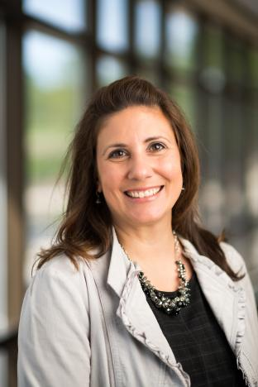**Kelly Ryan, Ph.D., ABPP-CN,** Clinical Associate Professor in the Neuropsychology Program, Department of Psychiatry. Dr. Ryan completed her undergraduate degree at the University of Michigan and earned her Ph.D. in clinical psychology from Wayne State University. She completed an APA accredited internship in clinical psychology (neuropsychology track) at the Ann Arbor Veterans Administration and an APA accredited postdoctoral fellowship in clinical neuropsychology at the University of Michigan. Her clinical interests include adult neuropsychological assessment, dementia, and other neurological and psychiatric disorders. Research interests include the use of neuropsychological tests to inform functional outcomes among medical and psychiatric populations, impact of neuropsychological functioning on patient and caregiver well-being, and cognitive, behavioral, and functional decline in aging. She also is interested in using technology to capture cognitive and functional shifts in mental illness. Email: [karyan@umich.edu](mailto:karyan@umich.edu)

**CLINICAL NEUROPSYCHOLOGY APPLICATION PROCESS**

The application deadline for the neuropsychology residency is **December 1, 2021**. Submission of materials is done electronically: [**https://medicine.umich.edu/dept/psychiatry/education/psychology-postdoctoral-training/how-apply**](https://medicine.umich.edu/dept/psychiatry/education/psychology-postdoctoral-training/how-apply)

Completed materials should include:

1) Application

2) Letter of interest/statement of future goals

3) Graduate school transcript

4) CV

5) Letter from DCT (this is separate from the 3 letters of recommendation)

6) 3 letters of recommendation

* We will not be participating in the 2020 APPCN match
* Applicants may express interest in more than one of the positions
* After a review of applications, individuals will be contacted for interview.
* Candidate Interviews take place in December and January via video/voice call

For further information please contact the Michigan Medicine Neuropsychology Program Training Director, Kristen Votruba, Ph.D., ABPP-CN at [kvotruba@med.umich.edu](mailto:kvotruba@med.umich.edu) or 734-936-6617.

**ANN ARBOR LIFE AND COMMUNITY**

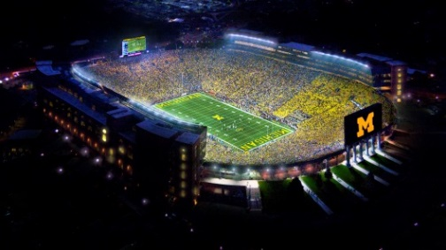Michigan Medicine and VA Ann Arbor Healthcare System are located within the mid-sized city of Ann Arbor. The 2010 Census recorded its population to be 113,934, making it the sixth largest city in Michigan. Ann Arbor is renowned for its cultural offerings and is home to an avid base of sport enthusiasts. Ann Arbor has you covered year-round, whether you enjoy arts, sports or recreational activities, shopping, festivals, casual or fine dining, family-friendly activities, or nightlife. Ann Arbor is also home to award winning public schools and higher learning universities and colleges. For further information please visit [www.visitannarbor.org](http://www.visitannarbor.org).

Photo: AACVB Photo: Chicago Tribune Photo: Angela J. Cesere | The Ann Arbor News

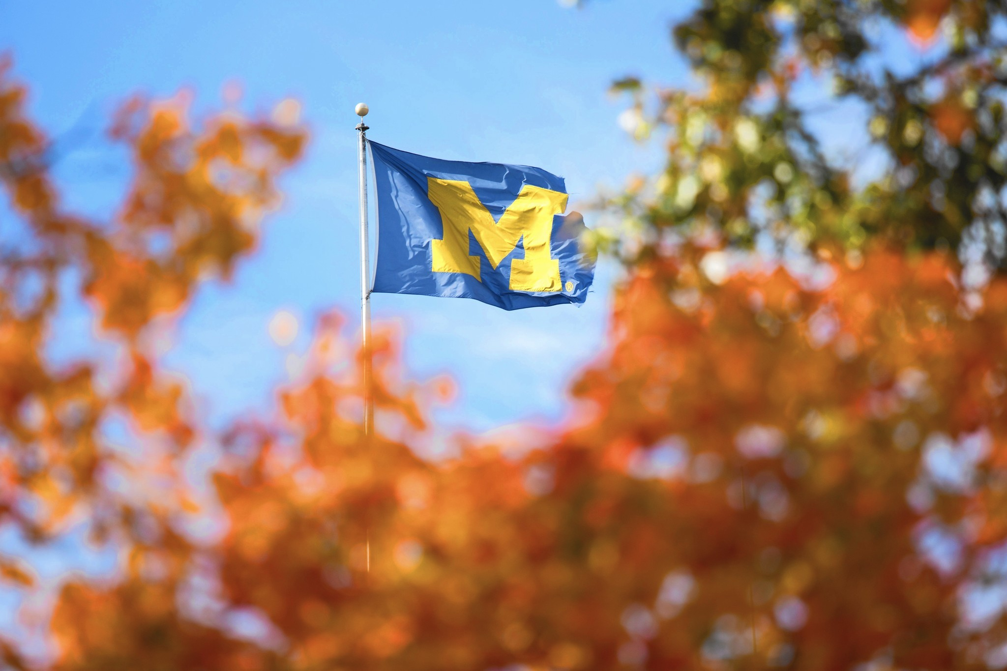





Awards and Accolades: (<https://www.visitannarbor.org/about>)

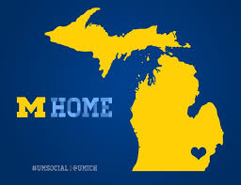

**2020**

[**Top 8 Up-and-Coming Small Cities Close to Major Metros**](https://livability.com/topics/where-to-live-now/dont-want-to-give-up-big-city-life-check-out-these-8-up-and-coming-small)**, Livibility, 2020**

[**America's Top 10 Best Small Cities**](https://www.bestcities.org/rankings/americas-best-small-cities/)**, Best Cities, 2020**

[**#1 Most Educated City in America**](https://wallethub.com/edu/e/most-and-least-educated-cities/6656/)**, WalletHub, 2020**

[**#1 Top Public University in America**](https://www.niche.com/colleges/search/top-public-universities/)**, Niche, 2020**

**2019**

[**University of Michigan Named 2018-2019 Best in College SportsOpens a New Window.**](https://www.cbssports.com/college-football/news/best-in-college-sports-michigan-edges-kentucky-to-bring-the-2018-19-award-to-ann-arbor/)**, CBS Sports, 2019**[**Ann Arbor is the #1 Location for Family VacationsOpens a New Window.**](https://vacationidea.com/weekend-getaways/best-family-vacations.html)**, Vacation Idea, 2019**[**Ann Arbor is One of the Top Unexpectedly Awesome Coffee CitiesOpens a New Window.**](https://livability.com/top-10/food-and-drink/10-unexpectedly-awesome-coffee-cities/mi/ann-arbor)**, Livibility, 2019**[**Ypsilanti Receives Smart 50 Award for InnovationOpens a New Window.**](https://www.smartresilient.com/smart-50-awards-recognize-innovation-and-impact)**, Smart & Resilient Cities, 2019**[**Ann Arbor is One of Top Cities for Older Americans in RetirementOpens a New Window.**](https://www.usatoday.com/story/money/2019/04/15/for-retirement-30-best-cities-for-older-americans/39331431/)**, USA Today, 2019**[**One of the Best Cities to Live in AmericaOpens a New Window.**](https://www.niche.com/places-to-live/search/best-cities/)**, Niche, 2019**

**2018**[**One of the Most Innovative Cities in AmericaOpens a New Window.**](https://michiganross.umich.edu/ross-news-blog/2018/12/10/ann-arbor-named-one-most-innovative-cities-us)**, 24/7 Wall St, 2018**[**Best Places to Live in America**](http://time.com/money/collection/2018-best-places-to-live/)**, TIME, 2018**[**Ypsilanti's East Cross Street named one of America's "Great Places,"Opens a New Window.**](https://www.planning.org/greatplaces/)**American Planning Association, 2018  
#1**[**Eastern Michigan University Recognized As Michigan’s Top LGBTQ-Friendly University**](https://www.affordablecollegesonline.org/college-resource-center/lgbtq-college-rankings-2018-2019/)**, AffordableCollegesOnline, 2018**[**Ypsilanti is One of the Most Affordable Destinations in AmericaOpens a New Window.**](https://www.budgettravel.com/video/affordable-discoveries-america)**, Budget Travel, 2018**[**One of the Best College Towns in AmericaOpens a New Window.**](https://wallethub.com/edu/best-worst-college-cities-and-towns-in-america/8974/)**, WalletHub, 2018  
#1**[**Most Educated City in America**](https://wallethub.com/edu/most-and-least-educated-cities/6656/)**, WalletHub, 2018  
#1**[**University of Michigan the Top Public University in U.S.**](https://www.clickondetroit.com/all-about-ann-arbor/ranking-university-of-michigan-no-1-public-university-in-us?beta=true)**, All About Ann Arbor, 2018**[**Cities With The Best Coffee in the United States**](https://www.nationalgeographic.com/travel/destinations/north-america/united-states/coffee-shops-cafe-small-cities-america/?beta=true)**, National Geographic, 2018  
#1**[**Top 100 Best Places To Live**](https://livability.com/list/top-100-best-places-to-live/2018/10)**, Livability.com, 2018  
#2**[**Top 10 Best Places to Raise a FamilyOpens a New Window.**](https://livability.com/top-10/families/10-best-places-to-raise-a-family/2018/mi/ann-arbor)**, Livability.com, 2018**[**Washtenaw County Businesses Among Fastest Growing in America**](https://www.ecurrent.com/news/washtenaw-businesses-among-fastest-growing-in-america/)**, Inc.com, 2018**

**2017  
#1**[**Ann Arbor: The Most Welcoming City for Active Daters in Michigan**](http://www.datingadvice.com/for-women/ann-arbor-a-welcoming-city-for-daters-in-michigan)**, DatingAdvice.com, 2017  
#1**[**2018's Best College Towns and Cities in AmericaOpens a New Window.**](https://wallethub.com/edu/best-worst-college-cities-and-towns-in-america/8974/)**, WalletHub, 2017  
#1**[**Best Cities to Live in AmericaOpens a New Window.**](https://www.niche.com/places-to-live/search/best-cities/)**, Niche.com, 2017  
#1**[**Most Educated Cities in AmericaOpens a New Window.**](https://wallethub.com/edu/most-and-least-educated-cities/6656/)**, WalletHub, 2017**[**Top 25 Happiest Cities in the United States.Opens a New Window.**](https://www.nationalgeographic.com/travel/destinations/north-america/united-states/happiest-cities-united-states-2017/)**, National Geographic, 2017  
#1**[**Best Mid-Sized Cities to Visit**](https://www.rewardexpert.com/blog/studies/rewardexperts-best-mid-sized-cities-to-visit-in-2017/)**, RewardExpert, 2017**[**The 10 Best Cities for Millennials In 2017.Opens a New Window.**](https://www.forbes.com/sites/jeffkauflin/2017/07/11/the-10-best-cities-for-millennials-in-2017/#253e2b5a15e0)**, Forbes, 2017**[**The 20 Happiest Cities to Work In Right Now**](http://www3.forbes.com/leadership/the-20-happiest-cities-to-work-in-right-now/2/)**, Forbes, 2017**[**Top 10 US Destinations for Solo Travel in 2017**](https://www.flipkey.com/blog/2017/03/25/top-10-us-destinations-for-solo-travel-in-2017/)**, FlipKey from TripAdvisor, 2017**[**The Top 10 Best US Cities for Entrepreneurs**](http://www.citi.io/2017/06/01/the-top-10-best-cities-for-entrepreneurs/)**, CITI.IO, 2017**[**The 19 Most Beautiful Libraries in the U.S.**](https://www.curbed.com/2017/2/9/14551106/best-libraries-architecture-united-states)**, Curbed, 2017**

**2016  
#1**[**The 10 Most Walkable Neighborhoods in the Midwest (Mid-Size City Edition)**](https://www.redfin.com/blog/2016/07/the-10-most-walkable-neighborhoods-in-the-midwest.html?utm_source=fbresearch&utm_medium=social&utm_campaign=1001966)**, Redfin.com, 2016**[**Expert Poll: Ranking the Best Towns in College Football**](http://athlonsports.com/college-football/expert-poll-ranking-best-towns-college-football)**, Athlon Sports & Life, 2016**[**The 15 U.S. Towns Most Worthy of a Day Trip**](http://www.esquire.com/lifestyle/cars/advice/g2709/top-us-towns-worthy-of-a-day-trip/?)**, Esquire, 2016**[**The Most Iconic Restaurant in Every Single U.S. State**](http://www.purewow.com/food/best-restaurant-in-every-US-state?utm_campaign=huffingtonpost.com&utm_source=pubexchange&utm_medium=syndication&utm_content=pubexchange_facebook)**, PureWow, 2016**