**32nd Reed M. Nesbit Urologic Society & Visiting Professor Meeting**

September 14-16, 2017





The Reed M. Nesbit Urologic Society, founded in 1972, holds an annual meeting for urologists who trained or were affiliated with the University of Michigan Department of Urology. It is open to residents, fellows, faculty and interested community urologists. This year’s program focuses on a wide range of urology topics.  The visiting professor for this year's event will be Dr. Robert Uzzo, Chair of the Department of Surgical Oncology at the Fox Chase Cancer Center. Additionally, Dr. John Allen of the University of Michigan Department of Gastroenterology will serve as the keynote speaker.

After attending this activity, participants will be able to:

1. Better understand a new, efficient approach to educating residents.
2. Utilize new approaches to diagnosing and treating prostate cancer in their practices, including focal therapies and MRI Biomarkers.
3. Implement innovative and effective new treatments of peyronie’s disease.
4. Improve the process of accepting and processing new patients by learning more about University of Michigan Urology’s Inpatient Process.
5. Learn how telemedicine can be implemented to improve patient outcomes.

The University of Michigan Medical School is accredited by the Accreditation Council for Continuing Medical Education (ACCME) to provide continuing medical education for physicians. The University of Michigan Medical School designates this live activity for a maximum of 8.5 AMA PRA Category 1 Credit(s)™. Physicians should claim only the credit commensurate with the extent of their participation in the activity.



**Michigan Medicine**

**Thursday, September 14, 2017**

**University of Michigan North Campus Research Complex (NCRC), 2800 Plymouth Road, Ann Arbor, MI 48109 - Building 18, Dining Hall**

1:00-1:30 PM **Registration (Lobby)**

1:30-1:45 PM **Welcome** – John Wei, MD, MS, Secretary-Treasurer, Nesbit Society

1:45-2:00 PM **"Telemedicine"**

Chad Ellimoottil, MD, MS

Assistant Professor, Department of Urology, Michigan Medicine

2:00-2:15 PM **"NPR"**

Priyanka Gupta, MD

Associate Professor, Department of Urology, Michigan Medicine

2:15-2:30 PM **"Access to Male Infertility Care"**

Jim Dupree, MD, MPH

Assistant Professor, Department of Urology, Michigan Medicine

2:30-2:45 PM **"Inpatient Process"**

Miriam Hadj-Moussa, MD

Assistant Professor, Department of Urology, Michigan Medicine

2:45-3:00 PM **Residency Training at Michigan**

Kate Kraft, MD

Assistant Professor, Department of Urology, Michigan Medicine

3:00-3:15 PM **"Focal Therapy PCA"**

Arvin George, MD

Assistant Professor, Department of Urology, Michigan Medicine

3:15-3:30 PM **Break**

3:30-4:15 PM **Case Presentation by Residents/Fellows**

#1 Amir Lebastchi, MD

#2 Tudor Borza, MD

#3 Amy Luckenbaugh, MD

4:15-5:00 PM **"Visiting Professor Lecture"**

Robert G. Uzzo, MD

Chair, Department of Surgical Oncology, Fox Chase Cancer Center

G. Willing "Wing" Pepper Chair in Cancer Research

Professor of Surgery, Temple University Health System



**Friday, September 15, 2017**

**University of Michigan North Campus Research Complex (NCRC), 2800 Plymouth Road, Ann Arbor, MI 48109 - Building 18, Dining Hall**

8:00-9:00 AM **Registration / Continental Breakfast**

9:00-9:15 AM **Welcome** – Mike Kozminski, MD, President, Nesbit Society

John Wei, MD, MS, Secretary-Treasurer, Nesbit Society

9:15-9:30 AM **"MRI Biomarkers PCA"**

John Wei, MD, MS

Professor, Department of Urology, Michigan Medicine

9:30-10:45 AM **"Visiting Professor Lecture"**

Robert G. Uzzo, MD

Chair, Department of Surgical Oncology, Fox Chase Cancer Center

G. Willing "Wing" Pepper Chair in Cancer Research

Professor of Surgery, Temple University Health System

10:45-11:00 AM **Break**

11:00-11:30 AM  **Guest Speaker Presentation**

John Allen, MD, MBA

Professor, Department of Gastroenterology, Michigan Medicine

11:30-12:00 PM **Department of Urology Group Photographs**

#1 All participants and guests

#2 Dr. Uzzo and Dr. Allen, faculty and residents

#3 Dr. Uzzo and Dr. Allen and faculty

#4 Faculty and residents

#5 Faculty

12:00-1:00 PM **Lunch**

NCRC Building 18, Dining Hall

1:00-1:15 PM **“Update on Peyronie’s Disease”**

Dana Ohl, MD

Professor, Department of Urology, Michigan Medicine



**Friday, September 15, 2017 (Continued)**

1:15–1:30 PM **"Bone Mets/PCA Lab Research"**

Evan Keller, PhD, DVM

Professor, Department of Urology, Michigan Medicine

1:30-1:45 PM **"CTC PCA"**

Todd Morgan, MD

Associate Professor, Department of Urology, Michigan Medicine

1:45-2:00 PM **“Complex Revision Surgery for Male Stress Urinary Incontinence”**

Bahaa Malaeb, MD

Assistant Professor, Department of Urology, Michigan Medicine

2:00-2:15 PM **"LURN Update"**

Anne Pelletier Cameron, MD

Associate Professor, Department of Urology, Michigan Medicine

2:15-2:30 PM **Break**

2:30-3:00 PM **Alumni Remarks: "46, XY DSD in XVII Century Colonial Spanish Celebrity"**

Mario Labardini, MD

Associate Clinical Professor, University of Texas South Western Medical School

3:00-3:15 PM **Alumni Remarks: “Reflection on Developing OUPF: Lesson Learned/Given”**

Tomohiko Koyanagi, MD

Emeritus Professor, Hokkaido University, President Jinyukai Hospital

3:15-3:30 PM “**Nesbit Molds to Gary Wedemeyer”**

Jay Hollander, MD

Professor and Program Director, Department of Urology, Oakland University William Beaumont

3:30-4:00 PM **State of the Department**

David A. Bloom, MD

The Jack Lapides Professor and Chair, Department of Urology, Michigan Medicine

4:00-4:30 PM **Reed Nesbit Business Meeting (*Members Only*)**

Mike Kozminski, MD, President, Nesbit Society

John Wei, MD, MS, Secretary-Treasurer, Nesbit Society

**Friday, September 15, 2017 - Social Program**

**Barton Hills Country Club, 730 Country Club Road, Ann Arbor, MI 48105**

**7:00 PM Reception - members and invited guests**

**7:30 PM Nesbit Society Reunion Dinner - members and invited guests**

**FROM M-14 WEST-BOUND**

Take Exit 4 - Whitmore Lake Rd/Barton Dr

Go straight across between stone pillars onto Barton Shore Drive, follow 2 miles to end. Then left on Barton North. Clubhouse at top of hill on right.

**FROM M-14 EAST-BOUND**

Take Exit 4 - Barton Drive

Right under overpass. After sharp curve, turn left between stone pillars onto Barton Shore Drive, follow 2 miles to end. Left on Barton North. Clubhouse at top of hill on right.

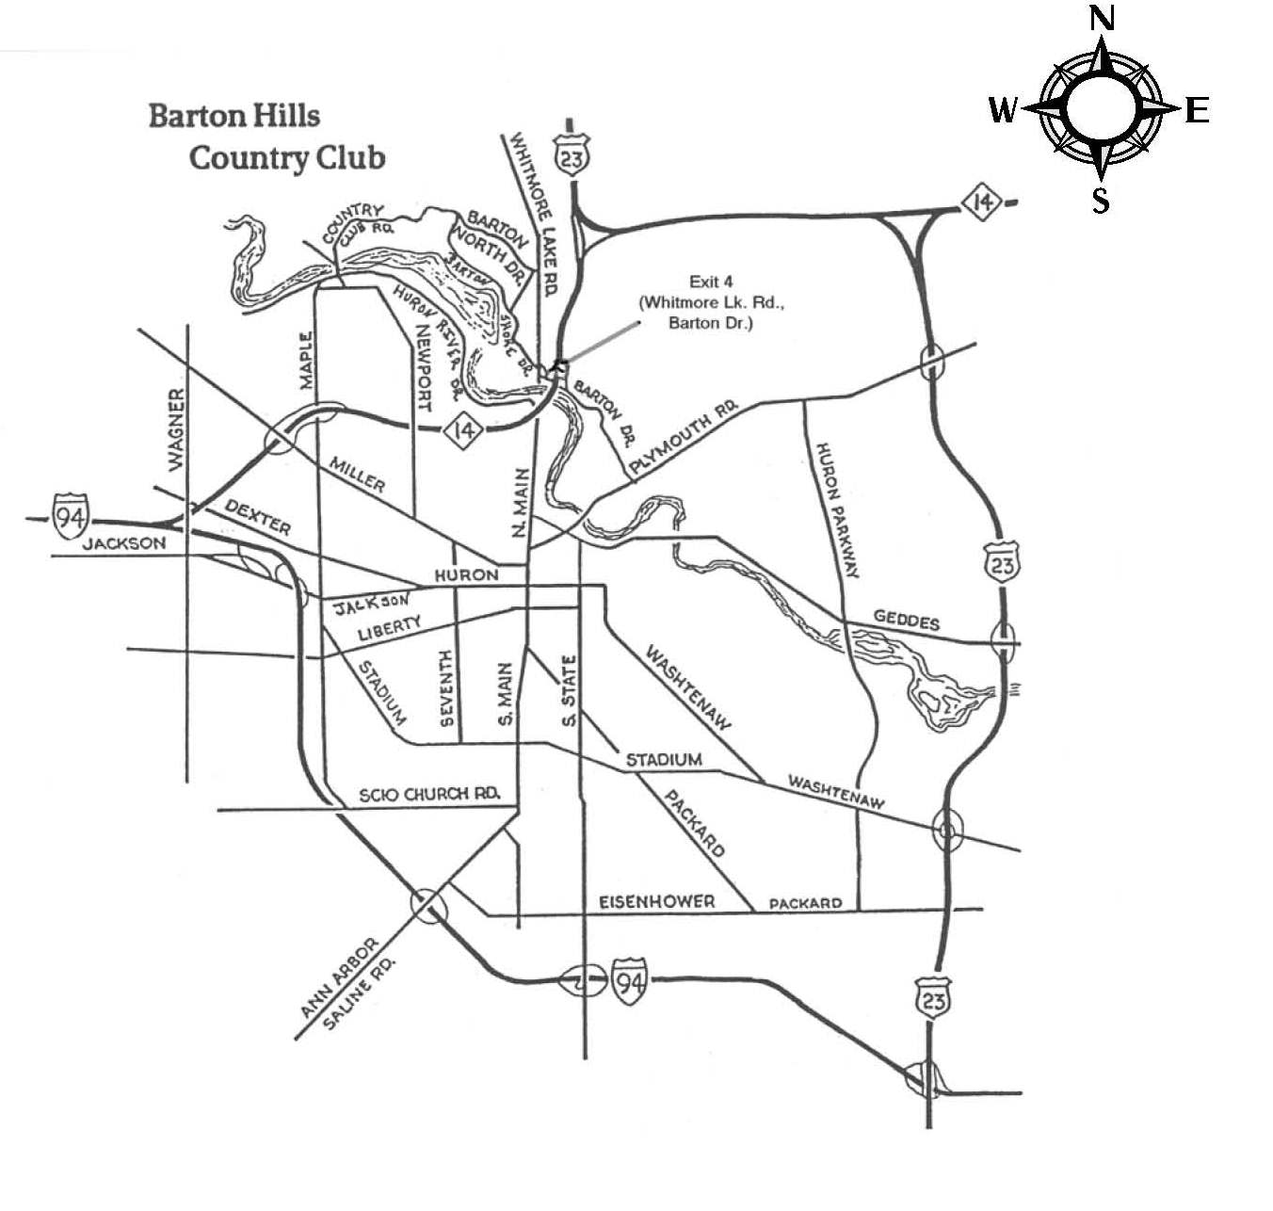

**by the GTH Building**

**Saturday, September 16, 2017 - Urology Department /Nesbit Society Tailgate**

**9:00 AM – 12:00 PM - Located behind the stadium by the GTH Building**

If you are attending this year’s Nesbit Meeting and would like to attend this football game, we’ve set up a link for you to purchase tickets through the Athletic Department.

Please visit [mgoblue.com/go/promo](http://mgoblue.com/go/promo) and enter the promo code NESBIT2017 to have access to the Nesbit Society’s ticket allotment. Tickets are $55 each plus a $10 service charge per order.

**In the North Parking Lot of the GTH Professional Building**

401 E. Stadium Blvd, Ann Arbor, Michigan (Next to the Crisler Arena Parking Lot)

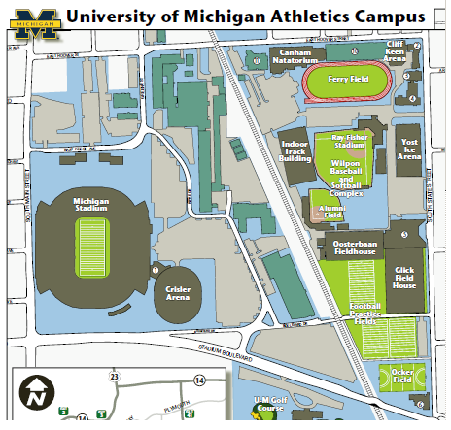



**Look for the Nesbit Flag**

**In the parking lot!**

**GTH Professional Building**

12:00 PM **Michigan vs. Air Force Football Game**

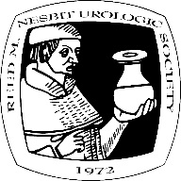 **Important Information**

**32nd Reed M. Nesbit Society & Visiting Professor Meeting**

**Thursday, September 14 - Friday, September 15, 2017**

**Registration Deadline - Due by August 31, 2017**

Please submit the enclosed Registration Form with payment by August 31st. You will receive confirmation receipt by e-mail. Nametags will be available at the scientific sessions on Thursday and on Friday.

**Airport Transportation**

Detroit Metro Airport (DTW) is located about 30 minutes East of Ann Arbor. Please contact one of the companies listed below to arrange for transportation to and from Detroit Metro Airport:

Arbor Limo 1-734-663-5959 $74.75 Metro to Ann Arbor or Ann Arbor to Metro (includes

Fuel surcharge and gratuities), town car, driver has sign with name

Accent Transportation 1-800-346-9884 $55 Metro to Ann Arbor/$45 Ann Arbor to Metro

Ann Arbor Metro 1-734-507-9220 $60 total Metro to Ann Arbor (1 or group) and $50 total

(1 or group), 7am-7pm, 7days

Blue Cab 1-734-547-2222 $55 approx. metered service Ann Arbor to Metro only

Metro Taxi & Limo 1-734-975-6898 $59 Metro to Ann Arbor/$49 Ann Arbor to Metro,

driver has sign with name

Scenic Transport 1-734-330-8726 $70 Metro to Ann Arbor/$70 Ann Arbor to Metro

Select Ride Shuttle 1-866-663-8898 $40 Metro to Ann Arbor/$33 Ann Arbor to Metro,

1 hr. pick-up window (If booking round trip price is $31 each way)

Yellow Cab 1-734-663-3355 $52 either way, Metro to Ann Arbor, or Ann Arbor to Metro

If you prefer to rent a car, maps to Ann Arbor will be available from the rental car companies.

**Hotel Information**

**A block of rooms have been reserved from September 13th thru 16th for our out-of-town guests.**

**The Courtyard by Marriott Ann Arbor** located at 3205 Boardwalk Drive, Ann Arbor at the special rate of $115.00 Wednesday/Thursday night and a rate of $319.00/Friday & Saturday nights (Guests are required to stay a minimum of 2-nights, Friday and Saturday evenings, with a 30-day cancellation policy during football weekends. Please call the Courtyard by Marriott Ann Arbor early at 734-995-5900 and specify the **"UM Urology Nesbit"** block of rooms. **The rooms will only be held until August 30, 2017.** For more information, visit: <http://www.marriott.com/arbch>.

**Holiday Inn** near the University of Michigan located at 3600 Plymouth Road, Ann Arbor at the special rate of $110.00 Wednesday/Thursday night and a rate of $239.00/Friday & Saturday nights (Guests are required to stay a minimum of 2-nights, Friday and Saturday evenings, with a 30-day cancellation policy during football weekends. Please call the Holiday Inn at 734-769-9800 early and specify the **"UM Urology Nesbit"** block of rooms. **The rooms will only be held until August 30, 2017.** For more information visit: <http://www.hiannarbor.com>

**Suggested Attire**

Business casual clothing is appropriate for the meeting and activities. Fall weather in Ann Arbor is variable, so be prepared for both cold and warm weather as well as rain.

**Directions and Parking**

**Thursday and Friday, September 14 and 15, 2017, University of Michigan**

**North Campus Research Complex (NCRC)**

**2800 Plymouth Road, Ann Arbor, 48109**

**From East (north side of town):** Take M-14 to US-23 south. Follow US-23 south to Plymouth Road exit (41); Turn right (west) onto Plymouth Road. Continue .9 miles to Huron Parkway. Go through the intersection at Huron Parkway and continue on Plymouth to Nixon Road. At Nixon (there is a light), get into the left turn lane which is at the 2800 Plymouth Road entrance to the North Campus Research Complex (there is a sign at the entrance). Enter the complex and follow the drive as it curves first to the right (near the Child Care Center) and then to the left past Building 16. Visitor parking will be on the left. Visitor entrance to the complex is at Building 18.

**From East (south side of town):** Take I-94 west to US-23 north. Follow US-23 north to Plymouth Road exit (41); Turn left onto Plymouth Road. Continue .9 miles to Huron Parkway. Go through the intersection at Huron Parkway and continue on Plymouth to Nixon Road. At Nixon (there is a light), get into the left turn lane which is at the 2800 Plymouth Road entrance to the North Campus Research Complex (there is a sign at the entrance). Enter the complex and follow the drive as it curves first to the right (near the Child Care Center) and then to the left past Building 16. Visitor parking will be on the left. Visitor entrance to the complex is at Building 18.

**From West (north side of town):** Take I-94 east to M-14 (goes northeast). Take M-14 to US-23 south. Follow US-23 south to Plymouth Road exit (41); Turn right (west) onto Plymouth Road. Continue .9 miles to Huron Parkway. Go through the intersection at Huron Parkway and continue on Plymouth to Nixon Road. At Nixon (there is a light), get into the left turn lane which is at the 2800 Plymouth Road entrance to the North Campus Research Complex (there is a sign at the entrance). Enter the complex and follow the drive as it curves first to the right (near the Child Care Center) and then to the left past Building 16. Visitor parking will be on the left. Visitor entrance to the complex is at Building 18.

**From West (through downtown):** Take I-94 to Jackson Road exit. Go east on Jackson Road which becomes Huron Street. Follow Huron Street east to Division Street. Turn left (north) on Division Street. Follow Division north as it goes over the Broadway bridge and becomes Broadway Street. Follow Broadway until it merges with Plymouth Road, just past Maiden Lane. Continue east on Plymouth Road (get in the right lane) to Nixon Road. At Nixon (there is a light), turn right at the 2800 Plymouth Road entrance to the North Campus Research Complex (there is a sign at the entrance). Enter the complex and follow the drive as it curves first to the right (near the Child Care Center) and then to the left past Building 16. Visitor parking will be on the left. Visitor entrance to the complex is at Building 18.

**From North:** Take US-23 south to Plymouth Road exit (41). Turn right (west) onto Plymouth Road. Continue .9 miles to Huron Parkway. Go through the intersection at Huron Parkway and continue on Plymouth to Nixon Road. At Nixon (there is a light), get into the left turn lane which is at the 2800 Plymouth Road entrance to the North Campus Research Complex (there is a sign at the entrance). Enter the complex and follow the drive as it curves first to the right (near the Child Care Center) and then to the left past Building 16. Visitor parking will be on the left. Visitor entrance to the complex is at Building 18.

**From South:** Take US-23 north to Plymouth Road exit (41). Turn left onto Plymouth Road. Continue .9 miles to Huron Parkway. Go through the intersection at Huron Parkway and continue on Plymouth to Nixon Road. At Nixon (there is a light), get into the left turn lane which is at the 2800 Plymouth Road entrance to the North Campus Research Complex (there is a sign at the entrance). Enter the complex and follow the drive as it curves first to the right (near the Child Care Center) and then to the left past Building 16. Visitor parking will be on the left. Visitor entrance to the complex is at Building 18.

**Directions and Parking (Continued)**

**September 14-15, 2017, University of Michigan**

**North Campus Research Complex (NCRC), Dining Hall**

**2800 Plymouth Road, Ann Arbor, 48109**

Once you reach NCRC….

1. Please follow the signs and park in the NCRC Parking Deck (BLUE structure).
2. A parking attendant will be on-site to distribute a complimentary parking pass - mention you are attending the UM Urology/Nesbit Society Meeting.
3. Building 18 is right across the street (entrance indicated by the PURPLE circle) and signs will be available to help guide you to the Dining Hall.

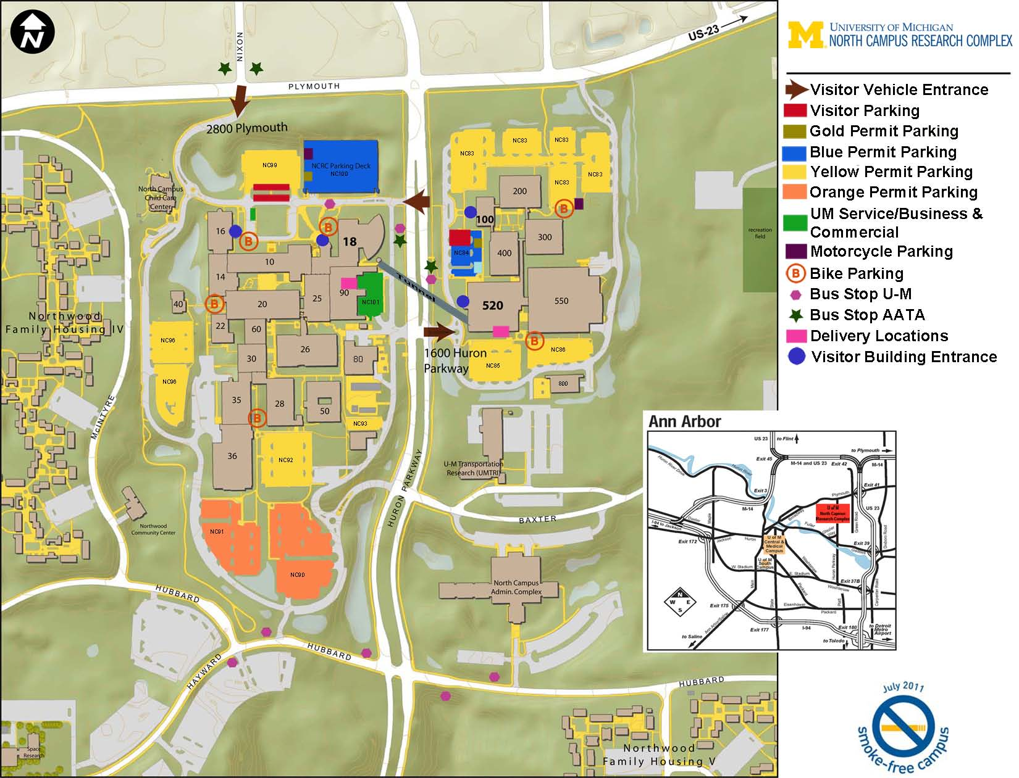

**Information/Questions:**

Please contact Tammie Leckemby at [tderry@umich.edu](mailto:tderry@umich.edu) or 734-936-8847 if you have any further questions   
or need assistance.