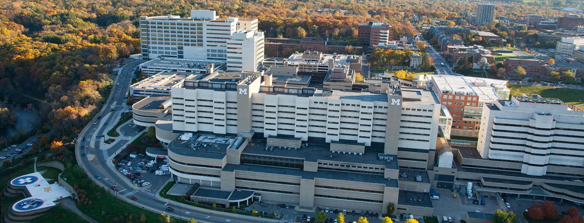

**University of Michigan Health PGY2 Oncology Residency Program**

Our program is designed to provide residents with a diverse set of experiences in hematology/oncology, while allowing collaboration with top experts at an **NCCN-designated Comprehensive Cancer Center**. The program will challenge residents to develop high-level clinical and literature evaluation skills through a wide variety of inpatient and outpatient experiences. The strong affiliation with the **University of Michigan College of Pharmacy** allows residents to hone educational skills through didactic lectures, round table discussions, and precepting of fellows, residents, students. Upon completion of the program, residents will be among the **leaders and best** in hematology/oncology practice, poised to secure a specialized pharmacist position in hematology/oncology.

Required:

* Orientation (July)
* Adult Inpatient Hematology
* Inpatient Bone Marrow Transplant
* Pediatric Hematology/Oncology
* Ambulatory Oncology GI/GU/Lung (Blue)
* Ambulatory Oncology GYO/Melanoma/Breast (Gold)
* Oncology Administration (2 weeks)
* Longitudinal Clinics (1 per semester)
  + Disease-based clinics (e.g., lung cancer)

Optional (see below)

* 14+ Available Clinics
* 10+ Inpatient Services
* Teaching/Academia, Oncology Quality
* Design & completion of a research project
* Completion of a writing project (review or secondary research project) suitable for publication
* Major topic presentations to heme/onc preceptor group every other month
* Service on professional committees (local & state/national)
* National meetings: Midyear Clinical Meeting, HOPA, Great Lakes Pharmacy Resident Conference
* Participation in Resident Wellness Activities
* Adjunct Clinical Instructor appointment
  + Preceptor for APPE and IPPE students
  + Teaching at the College of Pharmacy
  + ACPE Accredited CE to department

**Rotation Experiences**

**Other Core Experiences**

**Operational Responsibilities**

* Requires graduation from ASHP-Accredited PGY1 Pharmacy program & Michigan licensure by 11/1
* Competitive salaries & medical benefit coverage
* 15 vacation/sick/interview days
* Program Director: Allison Schepers, PharmD, BCOP

**Other Key Information**

* Cancer Center Infusion Staffing (2 shifts per month; Friday evening, Saturday day)
* Work 2 Holiday Blocks (1 major, 1 minor)

**Why Choose University of Michigan Health?**

Being part of something greater, of serving a larger mission of discovery and care — that's the heart of what drives people to work at Michigan. In some way, great or small, every person here helps to advance this world-class institution. It adds a purpose to your profession. Train at the University of Michigan and become a victor for the greater good.

|  |  |  |  |
| --- | --- | --- | --- |
|  | **Longitudinal Rotations** (4 hours per week; ½ year) – 2 elective clinics per year | | |
| **Rotation** | **Preceptor(s)** | **Required or Elective** |
| Lymphoma Clinic | Victoria Nachar, PharmD, BCOP  Iman Ahmed, PharmD, BCOP | Two required for longitudinal experience |
| Multiple Myeloma Clinic |
| Leukemia Clinic | Lydia Benitez, PharmD, BCOP |
| Bone Marrow Transplant Clinic | David Frame, PharmD  Tate Feeney, PharmD, BCOP |
| Gold Clinics | Gynecologic Oncology Clinic | Catherine Christen, PharmD |
| Melanoma Clinic | Shawna Kraft, PharmD, BCOP |
| Breast Cancer Clinic |
| Blue Clinics | Genitourinary Cancer Clinic |
| Head/Neck Cancer Clinic | Rachel McDevitt, PharmD, BCOP  Allison Schepers, PharmD, BCOP |
| Gastrointestinal Cancer Clinic |
| Sarcoma Clinic |
| Lung Cancer Clinic |
|  | Oral Chemotherapy Clinic | Anna Kempke, PharmD, BCOP, BCPS |

|  |  |  |
| --- | --- | --- |
| **Block Rotations**(May repeat any required rotation; electives may be 2-4 weeks in length) | | |
| **Rotation** | **Preceptor(s)** | **Required or Elective** |
| Orientation | Prabha Vogel, PharmD, BCOP, BCPS | Required (July) |
| Adult Inpatient Hematology (MHE) | Bernard Marini, PharmD, BCOP  Anthony Perissinotti, PharmD, BCOP  Martina Fraga, PharmD, BCOP | Required |
| Inpatient Hematology (MHP) | Elective |
| Inpatient Oncology (MON) | Alanna Lehman, PharmD, BCOP | Elective |
| Inpatient Bone Marrow Transplant | Denise Markstrom, PharmD  Gianni Scappaticci, PharmD, BCOP | One BMT rotation required |
| Pediatric Hematology/Oncology | Julia Brown, PharmD  Madeleine King, PharmD, BCOP | Required |
| Oncology Administration | Emily Mackler, PharmD, BCOP  Prabha Vogel, PharmD, BCOP, BCPS | Required (2 weeks min and longitudinal leadership series) |
| Ambulatory Oncology GI/GU/Lung (Blue) | Rachel McDevitt, PharmD, BCOP  Shawna Kraft, PharmD, BCOP  Allison Schepers, PharmD, BCOP | Required  (Blue & Gold; 2 months; do not have to be consecutive; Maize/Leukemia is elective)* |
| Ambulatory Oncology GYO/Melanoma/Breast (Gold) | Catherine Christen, PharmD  Shawna Kraft, PharmD, BCOP |
| Ambulatory Hematology (Lymphoma/  Myeloma/Leukemia) | Iman Ahmed, PharmD, BCOP  Lydia Benitez, PharmD, BCOP  Victoria Nachar, PharmD, BCOP |
| Ambulatory Bone Marrow Transplant | Tate Feeney, PharmD, BCOP  David Frame, PharmD | Elective |
| Hematology Consult Service | Madeleine Ochs, PharmD, BCOP | Elective |
| Infectious Diseases | Samuel Aitken, PharmD, MPH, BCIDP  Greg Eschenauer, PharmD, BCPS, BCIDP  Jerod Nagel, PharmD, BCPS, BCIDP | Elective§  §ID topics will also be covered in IP Adult Hematology and IP BMT rotations |
| Medical ICU | Michael Kenes, BCCCP, BCPS  Megan Ingebrigtson, BCCCP | Elective |
| Teaching/Academia | Shawna Kraft, PharmD, BCOP  Lydia Benitez, PharmD, BCOP | Elective |

*The following ambulatory oncology clinics are required, either longitudinally or in the month-long blocks: breast cancer, colorectal/pancreatic cancer, melanoma, lung cancer, ovarian cancer, prostate cancer