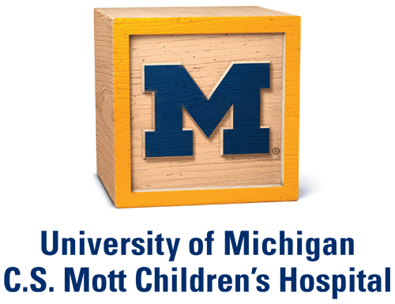

University of Michigan C.S. Mott Children’s Hospital
Department of Pediatrics Fellow Applicant Travel Scholarship

Purpose
Among the core missions of the University of Michigan Department of Pediatrics and C.S. Mott Children’s Hospital are:
- To improve health care by making new scientific discoveries on the cell and molecular level; and
- To eliminate racial, ethnic and socioeconomic disparities in health and health services.
To help accomplish these goals, the Department of Pediatrics is establishing a “Core Mission Travel Scholarship” to offset the travel costs of fellowship applicants interested in either cell and molecular biology or health disparities research.

Eligibility
Eligible candidates must complete an ACGME accredited pediatric or pediatric-medicine residency prior to beginning fellowship, hold an unrestricted license to practice medicine in the United States or Canada, and be United States citizens or permanent residents. University of Michigan residents are not eligible. In addition, applicants shall meet the following criteria:
- Intention to apply to a University of Michigan Pediatric Fellowship Training Program
- Demonstrated commitment to either:
1. Basic science research or
2. Health disparities research or caring for medically-underserved pediatric populations

Award Details
Ten scholarships of up to $1000 each will be awarded to resident applicants meeting the above criteria. Funds will support travel and lodging costs for two interview days in Ann Arbor, Michigan, home of the University.

As part of their interview, scholarship recipients will meet with faculty members from their subspecialty of interest who are familiar with the University of Michigan community. Scholarship recipients will also attend an informal dinner with faculty experienced in either basic science or health disparities research, according to the applicants’ research interests. This setting will enable scholarship recipients to receive detailed information about research opportunities at the University of Michigan and life in Ann Arbor.

Application Requirements
- Application to the fellowship program of interest through ERAS
- Completed Core Mission Travel Scholarship application -- the application form may be found at:
https://umich.qualtrics.com/SE/?SID=SV_6strW8zDGKL29St

The Department of Pediatric Fellowships are committed to a policy of nondiscrimination and equal opportunity for all persons regardless of race, color, national origin, age, marital status, gender, sexual orientation, gender identity, gender expression, disability, religion, height, weight, or veteran status. Fellowships follow the Graduate Medical Education policy on eligibility and selection. Note: The scholarship application process is independent from the fellowship application process. Receipt of a travel scholarship does not guarantee acceptance for the fellowship.

