If you do not wish to receive future fax broadcast messages please contact M-LINE at 800-962-3555 (FAX 734-615-5886).*

University of Michigan Department of Urology
Annual Weisbach Lecture
Targeting the Androgen Axis in Prostate Cancer:
Successes and Failures in Translational Research

Monday, November 18, 2019
11 a.m. – 1 p.m.
Ford Auditorum, University Hospital
1500 Medical Center Drive, Ann Arbor, MI

AGENDA
11:20 Lunch, Ford Auditorium lobby
11:45a.m. Welcome by Dr. Ganesh Palapattu, Chair, Department of Urology
12:00 p.m. Introduction Dr. Todd Morgan, Division Chief, Urologic Oncology
12:10 p.m. Lecture by Dr. Christopher Paul Evans
1:00 p.m. Q&A Wrap up

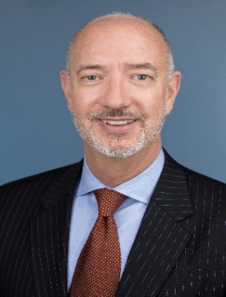
Visiting Professor
Christopher Evans, M.D., FACS, is professor and chairman of the Department of Urologic Surgery at University of California, Davis School of Medicine and a member of the UC Davis Comprehensive Cancer Center.
Dr. Evans’ research laboratory focuses on prostate cancer; specifically, mechanisms signaling the androgen receptor to activate prostate cancer growth and progression following castration.
For lunch and parking purposes, please RSVP via M-LINE at 1-800-962-3555 or email Joyce Lewis at babygirl@med.umich.edu.
*Failure to comply with your request constitutes a violation of federal law. In order to be effective, your request must (1) identify the telephone number or numbers of the telephone facsimile machine or machines to which your request relates and (2) be sent to the telephone number or facsimile number provided by this notice. In order to preserve your right to bring a claim against Michigan Medicine, you may consent to Michigan Medicine sending you future advertisements.

